CURRICULUM VITAE
Dr. Peter Kopčanský
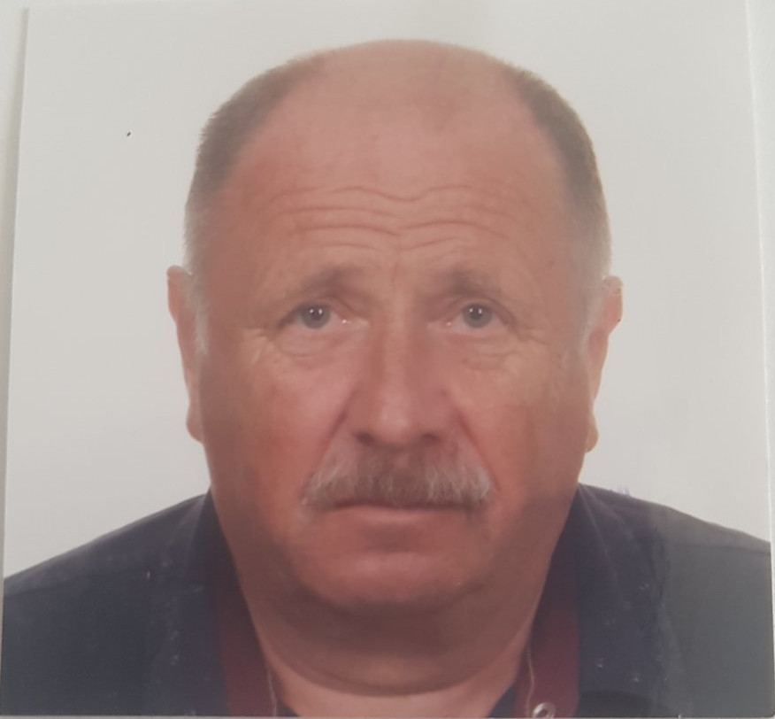
Affiliation and official address:
Institute of Experimental Physics SAS, Watsonova 47, 040 01 Košice, Slovak Republic
Phone: +421 55 7922259
Fax: +421 55/6336292
E-mail: kopcan@saske.sk
Date and place of birth: 02.12.1955; Zakamenne, Slovakia
Nationality: Slovak
Language ability: Slovak, Russian, English, German
Scopus profile: https://www.scopus.com/authid/detail.uri?authorId=7003616265
ORCID profile:
https://orcid.org/0000-0002-5278-9504
ResearchGate profile:
https://www.researchgate.net/profile/Peter-Kopcansky

Education/Career:
1980 – Graduate of Faculty of Sciences Safarik University,Kosice
1985 – PhD degree in the field of condensed matter physics at the Safarik University
1989 – Senior research fellow at Institute of Experimental Physics SAS
1991-2007 and 2015-2019 – Director of Institute of Experimental Physics SAS
1998 – Leading/research professor at Institute of Experimental Physics SAS
2006 – Honorary Doctor of Uzhhorod National University

Specialization:
-composite systems containing liquid crystals (traditional as well as biological);
-magnetic nanoparticles used in nanotechnology of magnetic fluids;
-increasing lifetime of high-power transformers;
-biomedical applications of magnetic fluids for magnetic drug targeting;
-biomedical applications of magnetic fluids for immobilization of biologically active substances enzymes, proteins and drugs;
-study of magnetoferritin and its biological properties; hyperthermia and MRI in these systems;
-structural study of investigated systems by X-ray and neutrons.

Scientific projects:
- PSI Villigen
- Petra III DESY Hamburg
- BNC Budapest
- JINR Dubna
- ILL Grenoble
- MHZ Munich

Scientific Activities:
- member of committee for selection of proposals ILL Grenoble
- member of committee for selection of proposals JINR Dubna
- superviser of many national and international projects: PI, British council, NATO, 5FP of EU, Euronanomed, Era net, COST, Slovak SAS-Taiwan MOST projects
- head of Centre of excellence: Cooperative and phase phenomena in condensed matter physics,
- head of Centre of excellence NANOFLUID
- chairman and organizator of over 30 international conferences
- over 60 invitations to give plenary and invited talks.

Number of thesis supervised: 16 defended PhD students.

Publication Scientific activity: 2 books, 5 chapters in books, 11 patents,
over 300 papers in high profile journals
(total citations –over 3000, h-index = 27)

List of selected publications in 2016-2021

1. Biasing a ferronematic – a new way to detectweakmagneticfield
Tomašovičová, Natália - Kováč, Jozef - Raikher, Yuriy - Éber, Nándor - Tóth-Katona, Tibor - Gdovinová, Veronika - Jadzyn, Jan - Pinčák, Richard – Kopčanský,Peter. In Soft Matter, 2016, vol. 12, no. 26, p. 5780-5786. (3.798 - IF2015). (2016 - CurrentContents). ISSN 1744-683X.

2.Tuning the phase transition temperature of ferronematics with a magnetic field
Toth-Katona, T; Gdovinova, V; Tomasovicova, N; Eber, N ; Fodor-Csorba, K ; Jurikova, A; Zavisova, V; Timko, M ; Chaud, X; Kopcansky, P , Soft Matter, Volume: 14, Issue: 9, Pages: 1647-1658, DOI: 10.1039/c7sm02383a ,Published: MAR 7 2018 IF: 3.889,Quartile in Category: Q1
3.Morphology and magnetic structure of the ferritin core during iron loading and release by magnetooptical and nmr methods
Koralewski, M; Balejcikova, L; Mitroova, Z; Pochylski, M; Baranowski, M Mikolaj ; Kopcansky, P , ACS Applied materials & Interfaces ,Volume: 10, Issue: 9, Pages: 7777-7787, DOI: 10.1021/acsami.7b18304, Published: MAR 7 2018, IF: 7.504, Quartile in Category: Q1

4.Particle assembling induced by non-homogeneous magnetic field at transformer oil-based ferrofluid/silicon crystal interface by neutron reflectometry
Anatolii Nagornyi, Viktor I. Petrenko, Michal Rajnak, Igor V. Gapon, Mikhail V. Avdeev, B. Dolnik, Leonid A. Bulavin, Peter Kopcansky, Milan Timko, Applied Surface Science, 473 (2019) 912–917, https://doi.org/10.1016/j.apsusc.2018.12.197, IF: 4.439, Quartile in Category: Q1
5.State of aggregation and toxicity of aqueous fullerene solutions
Olena A. Kyzyma, Mikhail V. Avdeev, Olga I. Bolshakova, Pavel Melentev, Svetlana V. Sarantseva, Oleksandr I. Ivankov, Mikhail V. Korobov, Ivan V. Mikheev, Timur V. Tropina Martina Kubovcikova Peter Kopcansky, Volodymyr F. Korolovychh, Victor L. Aksenov, Leonid A. Bulavin, https://doi.org/10.1016/j.apsusc.2019.03.167, Applied Surface Science 483 (2019) 69–75, IF: 4.439, Quartile in Category: Q1

6.Ferromagnetic and antiferromagnetic liquid crystal suspensions:Experiment and theory
Sergii Burylov, Danil Petrov, Veronika Lacková, Katarína Zakutanská, Natalia Burylova, Alexey Voroshilova, Vyacheslav Skosara, Filippo Agrestid, Peter Kopčanský, NatáliaTomašovičová, Journal of Molecular Liquids, MOLLIQ-114467; No of Pages 13, https://doi.org/10.1016/j.molliq.2020.114467, IF: 5,077, Quartile in Category: Q1
7.Electrical discharges in ferrofluids based on mineral oil and novelgas-to-liquid oil
Juraj Kurimsky, Michal Rajnak, Roman Cimbala, Katarina Paulovicova, Zbigniew Rozynek,
Peter Kopcansky, Milan Timko, Journal of Molecular Liquids 325 (2021) 115244, https://doi.org/10.1016/j.molliq.2020.115244, IF: 5,854, Quartile in Category: Q1
8.Birefringence dispersion of 6CHBT liquid crystal determined in VIS-NIR spectral range
Norbert Tarjányi , Marek Veveričík , Daniel Káčik , Milan Timko , Peter Kopčanský, Applied Surface Science 542 (2021) 148525, https://doi.org/10.1016/j.apsusc.2020.148525, IF: 6,612 Quartile in Category: Q1

9.Cotton textile/iron oxide nanozyme composites with peroxidase-like activity: preparation, characterization, and application
Ivo Safarik, Jitka Prochazkova, Martin A. Schroer,Vasil M. Garamus, Peter Kopcansky,Milan Timko, Michal Rajnak, Maksym Karpets, Oleksandr I. Ivankov, Mikhail V. Avdeev, Viktor I. Petrenko,Leonid Bulavin, and Kristyna Pospiskova, ACS Appl. Mater. Interfaces 2021, 13, 23627−23637, https://doi.org/10.1021/acsami.1c02154, IF: 8,758, Quartile in Category: Q1

10.Orientational self-assembly of nanoparticles innematic droplets
Natalia Tomasovicova,Marianna Batkova, Ivan Batko,Veronika Lackova,Vlasta Zavisova, Peter Kopcansky, Jan Jadzyn, Peter Salamoncand Tibor Toth-Katona, Nanoscale Advances, 2021,3, 2777–2781, DOI: 10.1039/d1na00089f, IF: 4,384,Quartile in Category: Q1

11.Controllability of ferrofluids’ dielectric spectrum by means of external electric forces
Michal Rajnak, Bystrik Dolnik, Jakub Krempasky, Roman Cimbala, Kinnari Parekh, Ramesh Upadhyay, Katarina Paulovicova, Peter Kopcansky and Milan Timko, Journal of Physics D: Applied Physics, 54 (2021) 035303 (11pp), https://doi.org/10.1088/1361-6463/abbeb6, IF: 3,541,Quartile in Category: Q1

