BIOGRAPHY
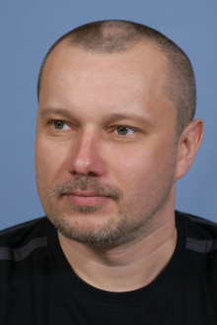
Family name, First name: Džunda Róbert
Date of birth: 16th October 1972
Nationality: Slovak
Contact address: Institute of Materials Research, Slovak Academy of Sciences,
Watsonova 47, 040 01 Košice, Slovak Republic,
E-mail: rdzunda@saske.sk
Phone: +421/55/7922 424
Fax: +421/55/7922408

- EDUCATION:
2019 PhD., Faculty of Materials, Metallurgy and Recycling, TUKE Košice, Slovakia
2012 Ing., Faculty of Materials, Metallurgy and Recycling, TUKE Košice, Slovakia

- CURRENT POSITION:
2019 - current Research employee
Institute of Materials Research, Slovak Academy of Sciences, Košice, Slovakia

- PREVIOUS POSITIONS:
2012 - 2019 Graduated technician
Institute of Materials Research, Slovak Academy of Sciences, Košice, Slovakia
1992 - 2012 Technician
Institute of Materials Research, Slovak Academy of Sciences, Košice, Slovakia

