



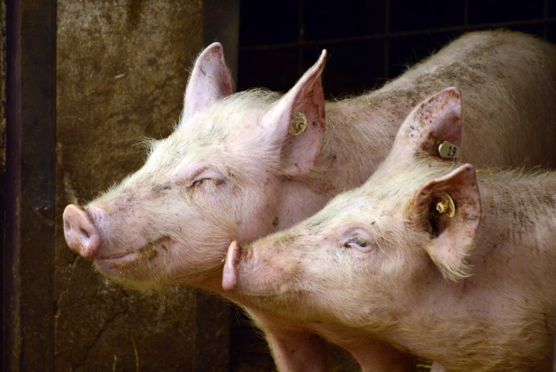
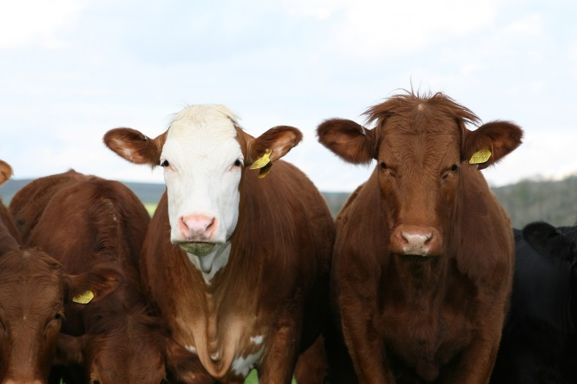



Call for Participants
Rome, Italy 27-29 April 2020

European Animal Production: Envisioning the Future

This ERA-NET receives funding from the European Union’s Horizon 2020 research and innovation programme under Grant Agreement n° 696231
Early Career Researcher Workshop

Envisioning the Future of European Animal Production

Workshop for Early Career Researchers

27-29 April 2020 in Rome, Italy

Conducted within the ERA-NET SusAn and hosted by MIPAAF, Italy

Submission deadline 20th February 15:00 CET

The European Research Area Network on Sustainable Animal Production (ERA-NET SusAn) was initiated 2016 under the current European research and innovation programme Horizon 2020. 38 partners from 23 European countries in ERA-NET SusAn endorsed scientific excellence and recommended an integrated, interdisciplinary, cross-cutting and multi-actor approach to research and knowledge exchange which reflects the complexity of the research requirements for sustainable European animal production. Based on the three pillars of sustainability - economy, environment and society – SusAn targets innovative research across all areas of the animal production system such as health and welfare, feeding and nutrition, reproduction, breeding and genetics, housing, nutrient management and economics.
What is the Early Career Researchers Workshop?
The Early Career Researcher Workshop is one of the additional activities of the ERA-NET SusAn on top of the cofunded call. By organising this event, ERA-NET SusAn aims to bring together European researchers in the early stages of post doc career to work together on a vision of European sustainable animal production.

The main objectives of this workshop are:
- Define key benefits and challenges of sustainable European animal production
- Discuss different alternatives/pathways to a more sustainable European animal production
- Elaborate a coherent vision for sustainable animal production in Europe and formulate a “Narrative of sustainable European animal production”
- Create the basis for a peer reviewed article on the narrative, to be completed after the workshop by the participants

What is the approach of the workshop?
Group work and plenary discussion will be the main activity. Short expert presentations on key issues will be included.

We suggest to integrate economic, environmental and societal aspects for a holistic view of sustainability in animal production systems. The SDGs of the UN Agenda 2030 and the COP 21 Paris Agreement shall serve as common reference. An interdisciplinary approach will cover several disciplines such as animal science, systems thinking, environmental science, human nutrition, socio-economics and political science.

A cross-scale approach could consider at least three levels of analysis:
(1) the animal/herd level will focus on technical approaches of animal housing, health and welfare, feed, breeding, precision livestock and manure management
(2) the farm/regional level will use a system approach to assess and design the whole production system
(3) the European/global level will consider the political science and public health perspective, including macroeconomics and planetary boundaries concepts.

Who is invited to participate?
Early Career Researchers with the following features are invited to send their application:
- In possession of a PhD degree, which was awarded within the five years preceding the submission deadline. For the purposes of this condition, the date of graduation will be taken into account
- Employed (on a temporary or permanent contract) by a university or research performing organisation in one of the ERA-NET SusAn consortium partner countries at the submission deadline
- Proficient in English
- Involved in and/or experienced with national and/or international research projects dealing with animal production, systems thinking, sustainable development or related fields. Experience in systems thinking will be preferred for the selection of applicants. Systems thinking perceives animal production as a complex set of interdependent system components like animal health, welfare, breeding, feeding, housing, manure management, etc. It investigates the animal production system as a whole and looks at how key components of the system can cause relevant changes of the system’s performance
- All required information must be provided in the application

Application Process
Please compile your application form (Annex A) including the following documents:
- Letter of motivation (Annex B)
- CV and list of publications (Annex C)
- Letter of recommendation from the head of your research department or equivalent confirming your eligibility and proficiency in English, signed and dated (Annex D)
Your applications should be submitted as a single pdf document (named institution.country.surname.name.pdf) on the SusAn website https://era-susan.eu/node/add/submission including the requested documents in the order given above until the 20th February 15:00 CET.

Selection Procedure
25 applicants will be selected according to the following evaluation criteria:

- Excellence of the Candidate
- Education and academic curriculum (scientific reputation of university, employment at different universities etc.)
- Demonstrated scientific excellence of the researcher appropriate to their career stage (e.g. publications, conference participation, granted patents, book chapters, leadership in industrial innovation)
- Research experience and relevant technical skills
- Other relevant experience (e.g. teaching, reviewing, consultancy, supervision, event organisation, public outreach)
- Scientific relevance
- Scientific relevance of the candidates’ research work with respect to the scope of ERA-NET SusAn (three pillars of sustainability in animal production)
- Motivation
- Coherence and quality of the Letter of Motivation
- Alignment with and personal interest in the scientific scope/approach of the workshop: holistic view of sustainability in animal production systems (transdisciplinarity, integration of economic, environmental and societal aspects in research)

Selection of applicants will seek geographical and gender balance. Travel, accommodation, meals and workshop participation will be funded by ERA NET SusAn.

ANNEX A

Application Form

By providing us with your personal details, you are confirming that you give your consent to process your personal details in order to check your eligibility and evaluate your application for ERA-NET SusAn Early Career Researchers Workshop. Your personal information will be kept confidential. Your personal data will be processed in compliance with the European Union General Data Protection Regulation (GDPR) Act 2018.

I agree that I as a participant might be photographed throughout the course of this workshop and respective photos might be published on https://www.era-susan.eu/.

Also, you are confirming that the information supplied in this application is correct and recognise that should it become apparent that any of the information provided is inaccurate or unverifiable with appropriate documentation, it will result in the application being deemed ineligible.

Please tick the box to confirm that you agree to the above terms and conditions and provide your signature below:
Agree

Signature
__________________

Type Full Name

NAME_____________________________________________________________________________

SURNAME__________________________________________________________________________

GENDER____________________________________________________________________________

DATE OF BIRTH DD.MM.YYYY____________PLACE OF BIRTH_________________________________

RESIDENCE TOWN_________________________ZIP CODE_________________________________

ADDRESS _________________________________________________________________________

PROVINCE_______________________________COUNTRY_________________________________

PHONE NUMBER___________________________________________________________________

E-MAIL___________________________________________________________________________

INSTITUTION_______________________________________________________________________

ADDRESS__________________________________________________________________________

TOWN ______________________________ZIP CODE_____________________________________

PROVINCE_______________________________COUNTRY_________________________________

DATE AND PLACE OF GRADUATION ___________________________________________________

Documents attached to this application:

- Letter of Motivation
- CV and list of publications
- Letter of Recommendation from the applicant’s head of research department or equivalent confirming the applicant’s eligibility and their proficiency in English, signed and dated

ANNEX B

TEMPLATE FOR THE LETTER OF MOTIVATION
Maximum 1 page, Arial 12 point font, single spacing

DD.MM.YY

For the attention of: ERA-NET SusAn Early Career Research Workshop organising committee

Dear Sir/Madam
…………………………………
……………………………..
Sincerely,

The letter of motivation should answer the following questions:
- What is your motivation for participating in the ERA-NET SusAn Early Career Researcher Workshop?
- What kind of value do you expect from attending the ERA-NET SusAn Early Career Researcher Workshop?
- What is your professional goal and how do you think you the Early Career Workshop will help you in reaching it?

Explain how the scientific scope of the workshop aligns with your personal interest, underlying the relevancy of your research work with respect to the scope of ERA-NET SusAn and in particular with the three pillars of sustainability in animal production.
*Instruction marked in red are to be deleted

ANNEX C

TEMPLATE FOR APPLICANT CV AND LIST OF PUBLICATIONS
Maximum 5 pages: CV (max 2 pages) + List of Publication (max 3 pages)

CURRICULUM VITAE (maximum 2 pages)

PERSONAL INFORMATION
[Name]
[Nationality]

APPLICATION FOR: Early Career Researcher Workshop – European Animal Production: Envisioning the Future

WORK EXPERIENCE:
[Month Year – Month Year] | [Position] (e.g. Post-doctoral researcher)
 | [Employer] (XYZ University, Address)
 | [Short work description]
[Month Year – Month Year] | [Position] (e.g. Post-doctoral researcher)
 | [Employer] (XYZ University, Address)
 | [Short work description]
……. | ………….

EDUCATION AND TRAINING:

[Year –Year] | [University, Country]
 | [PhD. – Thesis Title: XXXXX (if any)
[Year –Year] | [University, Country]
 | [MSc. – Thesis Title: XXXXX
[Year –Year] | [University, Country]
 | [B Sc. Thesis Title: XXXXXX]
……. | ………….

PERSONAL SKILLS
LANGUAGE SKILLS:
Mother tongue/s
Other language/s

INTERDISCIPLINARY SKILLS: eg. European networking, capacity to work in groups, to apply system thinking, etc.

OTHER SKILLS: eg. Computer skills, additional experience and knowledge in research methods, techniques, etc.

RESEARCH INTERESTS:

ADDITIONAL INFORMATION: [Research fellowships, grants, awards, extracurricular activities (teaching, reviewing, consultancy, supervision, event organisation, public outreach etc.)]

* Please delete all instructions marked in red; these are only examples, which you can follow if applicable.
** Please replace the fields highlighted in grey with the requested mandatory information.

LIST OF PUBLICATIONS
(maximum 3 pages)
- Peer-reviewed publications
- Manuscripts submitted to a peer review process
- Non-peer-reviewed publications
- Manuscripts submitted to a non-peer review process
- Books/Book chapters
- Conference/Congress contributions:
  - Posters
  - Oral presentations

ANNEX D

TEMPLATE FOR THE LETTER OF RECOMMENDATION
(Maximum 1 page, Arial 12 point font, single spacing)

A Letter of Recommendation is required from the applicant’s Head of Research Department (or equivalent). This letter must confirm that:
- The applicant is qualified to apply for the Early Career Researchers Workshop, i.e. the applicant is employed (on a temporary or permanent contract) by a university or research performing organisation in one of the ERA-NET SusAn consortium partner country (Austria, Belgium, Czech Republic, Denmark, Estonia, Finland, France, Germany, Greece, Ireland, Italy, Latvia, Lithuania, Netherlands, Norway, Poland, Portugal, Slovakia, Spain, Sweden, Turkey, UK).
- The applicant is proficient in English.

The letter must be signed and dated by the Head of Department (or equivalent) and submitted in pdf form.

*Instruction marked in red are to be deleted or replaced

**Please replace the fields highlighted in grey with the requested mandatory information.

DD.MM.YYYY

For the attention of: ERA-NET SusAn Early Career Researcher Workshop organising committee

Dear Sir/Madam,

I, undersigned, (name and surname)
___________________________________________________________________
Head of research department (or equivalent) of ___________________________

Declare the eligibility and the proficiency in English of the applicant

Name of the Applicant________________________________________________
Surname of the Applicant_____________________________________________

Sincerely,

[Signature]
________________________________
[Name
Position in university /organisation]

Date:_____________________

