Supplementary Figures

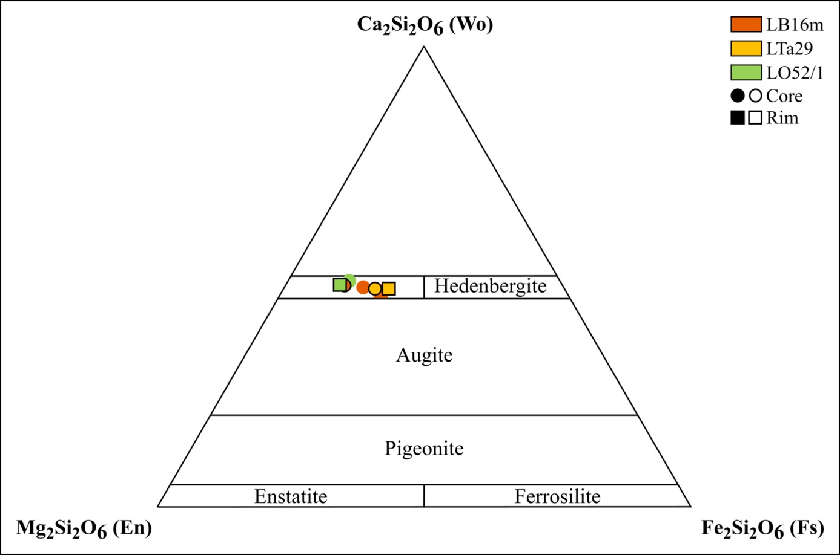
Fig. S1. Compositional variation of the analysed clinopyroxenes in terms of the En–Fs–Wo end-members (Morimoto et al. 1988). The clot-­forming and orbicular inclusion-derived clinopyroxene data are marked with symbols with a black rim.

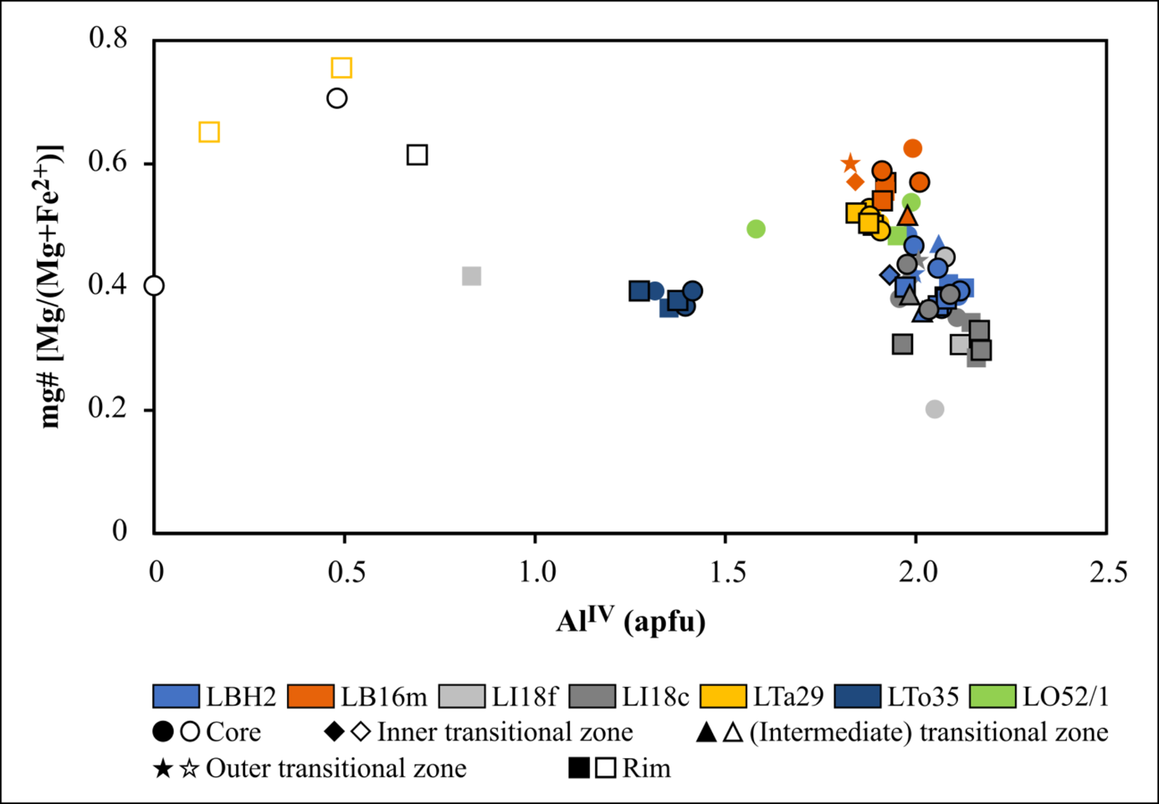
Fig. S2. Compositional variation of the analysed amphiboles in terms of their mg# and Al^{IV} concentration. Actinolite data are marked by empty symbols. The compositions of the clot-forming crystals are identified by symbols with a black rim.

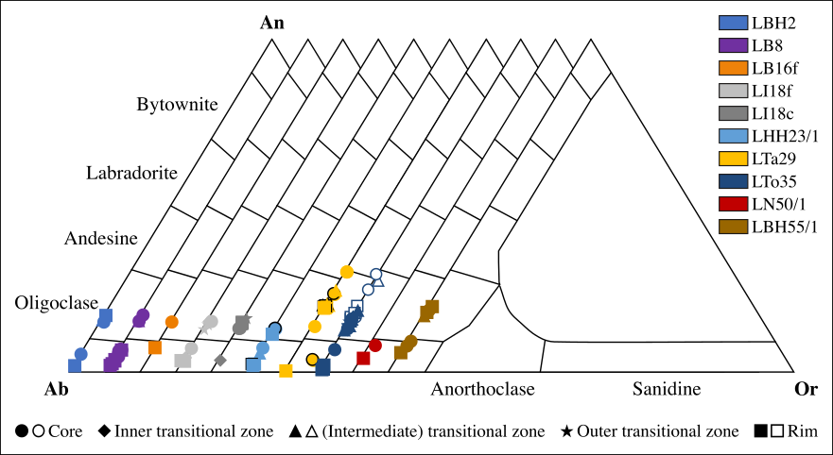
Fig. S3. Compositional variation of the analysed plagioclase crystals in terms of the Ab–An–Or end-members. Data of plagioclase in synneusis are marked by empty symbols. The composition of the clot-forming crystals is identified by symbols with a black rim.

