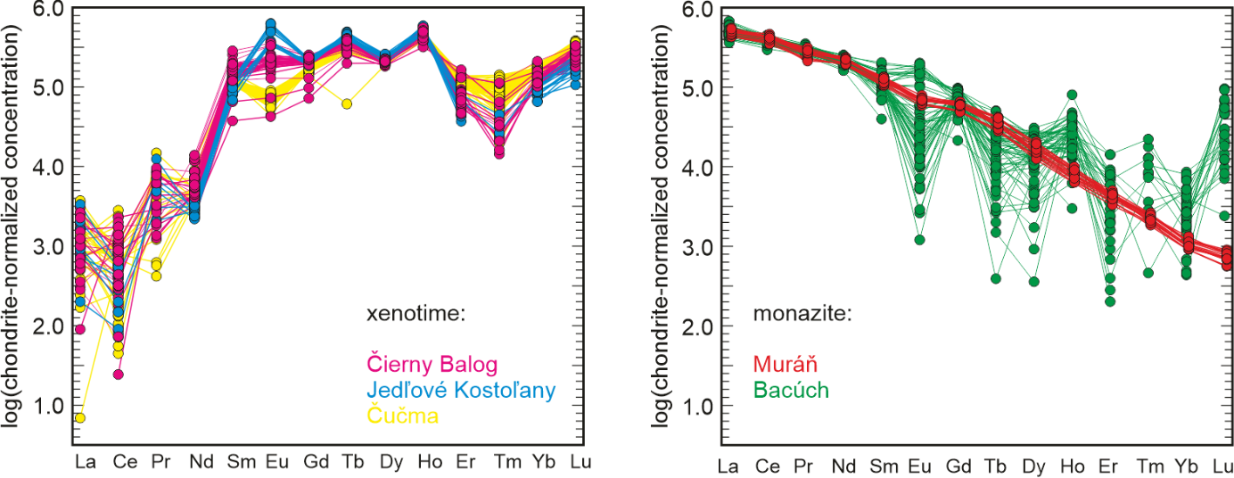

Fig. S1. Chondrite-normalized REE patterns of xenotime-(Y) and monazite-(Ce) from the studied samples. The data for the Muráň sample measured by LA-ICP-MS, the other data sets by electron microprobe. Note that the significant scatter for the REE with lower concentrations from the electron microprobe data are given by the fact that the concentrations were near the detection limit.

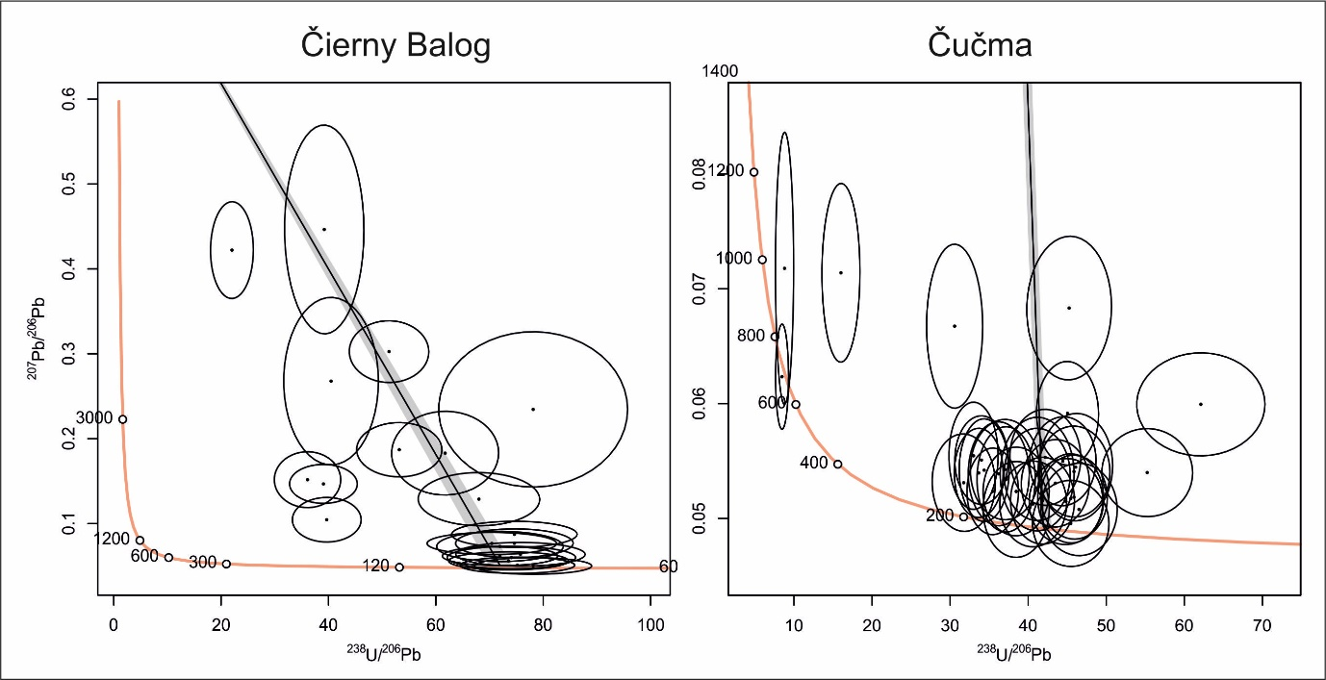

Fig. S2. Tera-Wasserburg diagrams for xenotime-(Y) from Čierny Balog and Čučma.

