Perlite deposits of the Central Slovakia Volcanic Field (Western Carpathians): Geology and properties
Electronic supplement 3: Samples for laboratory investigation
(Minerals abreviations: plg – plagioclase, kfs – K-feldspar, qtz – quartz, amph – amphibole, bt – biotite, mt – magnetite, ap – apatite, zrn – zircon, zeol – zeolite, spher – spherulite)
1. The Lehôtka pod Brehmi perlite deposit (rhyolite monogenetic volcano)
Macrophoto | Microphoto | BSE image of glass
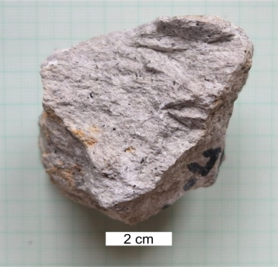 | 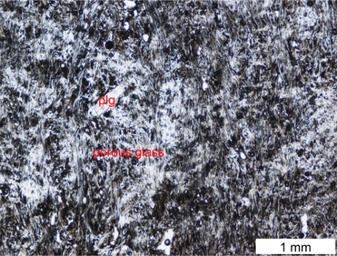 | 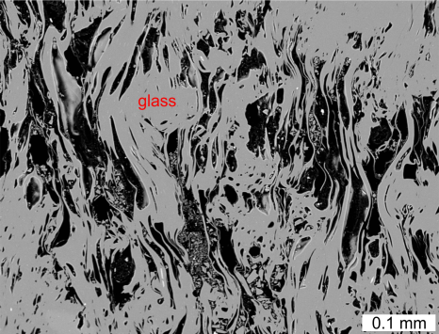
PL-4a (48 32 27.5N 18 48 31.5E): Angular fragment of a porous pale-grey perlite from the phreatomagmatic lapilli tuff, the lowermost unit in the western part of the deposit.
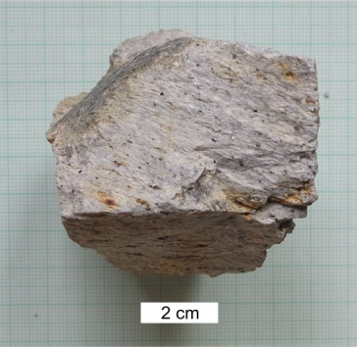 | 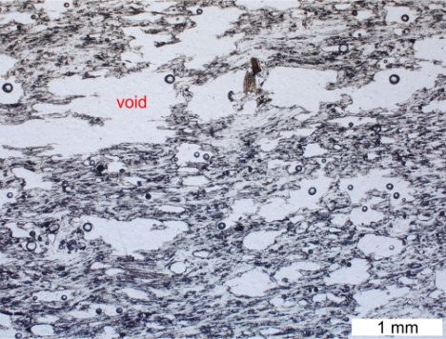 | 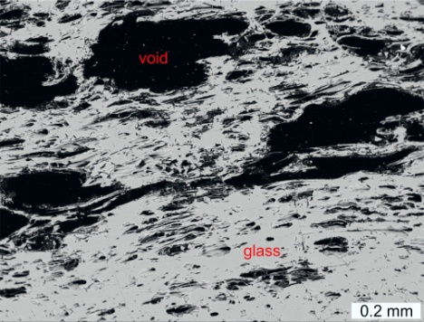
PL-4b (48 32 27.5N 18 48 31.5E): Angular fragment of flow-oriented pumiceous pale grey perlite from the phreatomagmatic lapilli tuff, the same unit as PL-4a.
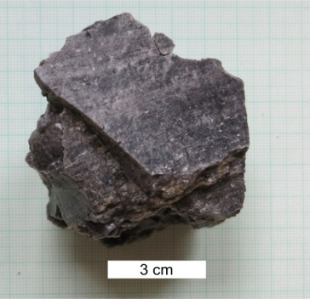 | 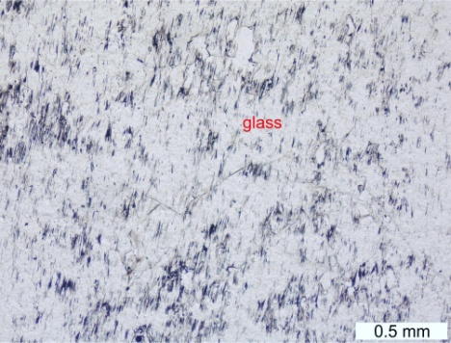 | 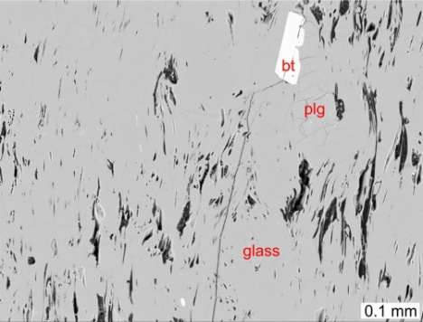
PL-6a (48 32 28.0N 18 48 35.6E): Angular fragment of a flow-oriented dark dense perlite from the phreatomagmatic breccia, the lowermost unit in the western part of the deposit.
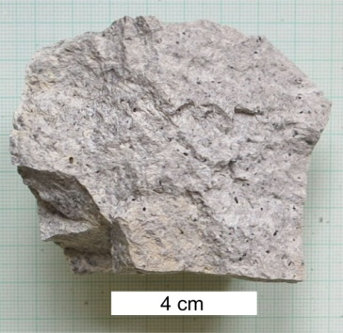 | 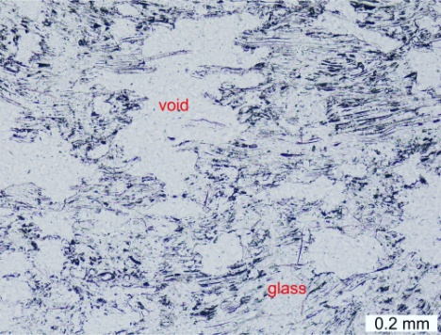 | 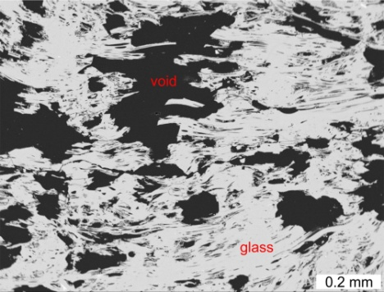
PL-6b: (48 32 28.0N 18 48 35.6E): Pale grey pumiceous perlite – a piece of chilled phreatomagmatic bomb in the phreatomagmatic breccia, the same unit as PL-6a.

Macrophoto | Microphoto | BSE image of glass
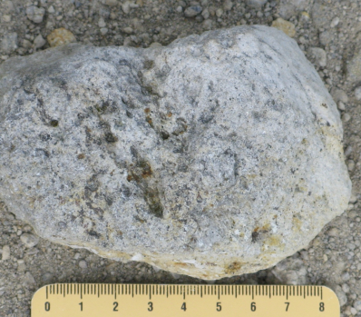 | 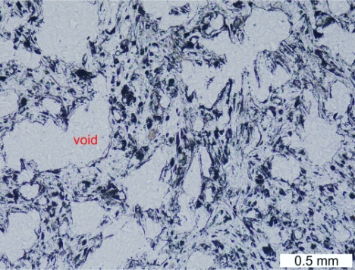 | 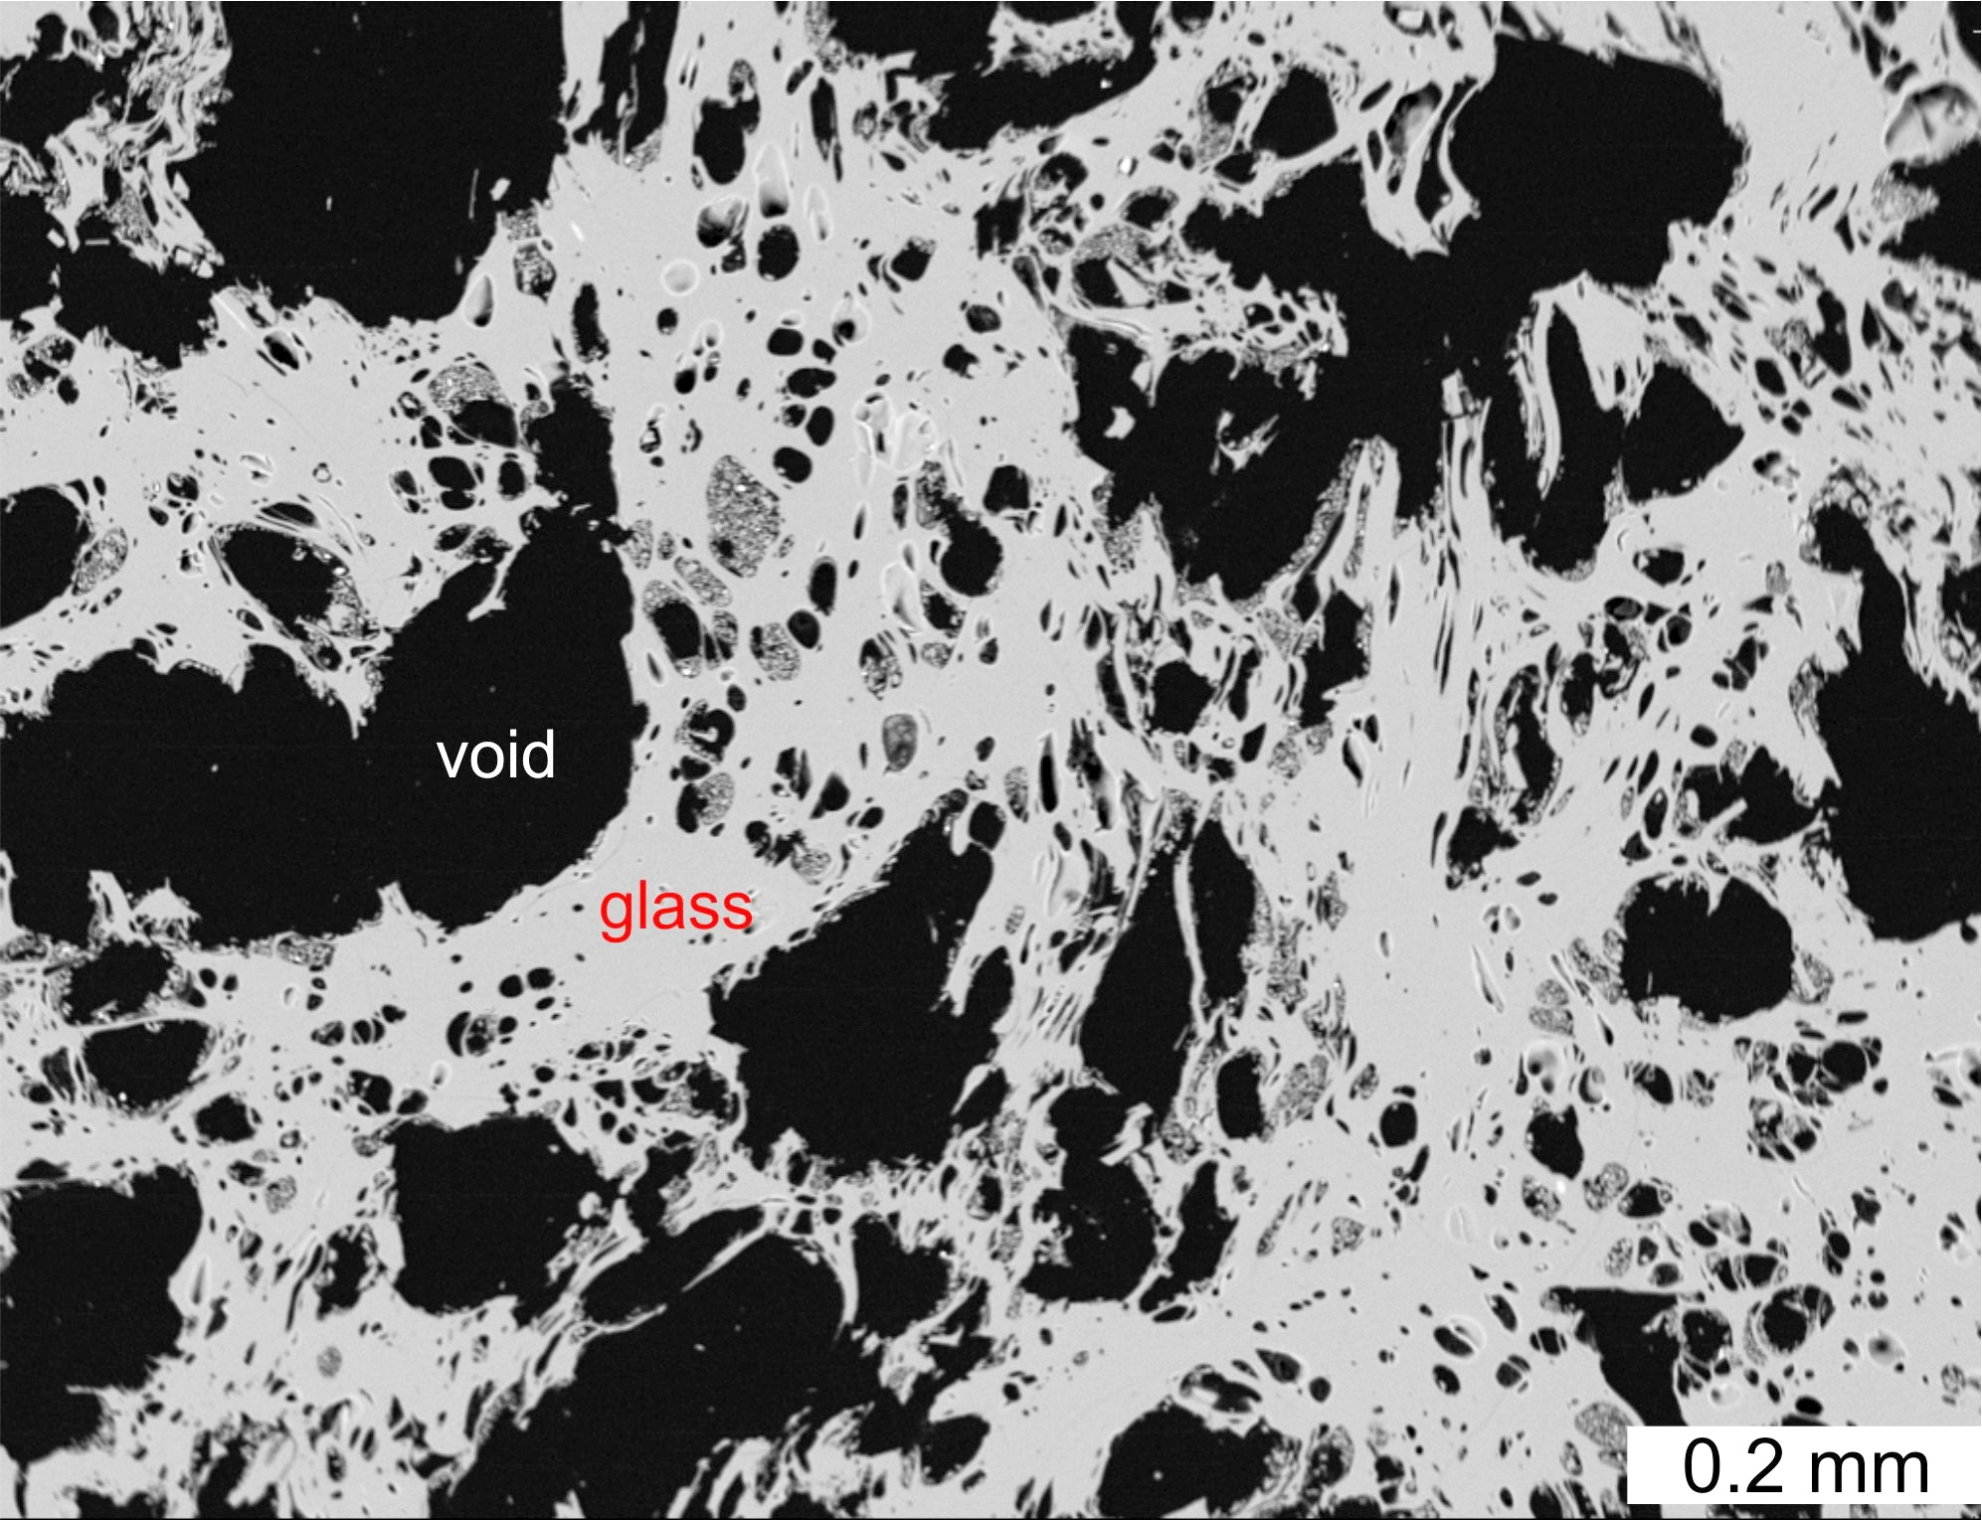
PL-10 (48 32 27.2N 18 48 36.8E): Spherical balistic fragment of pumiceous pale grey perlite from the phreatomagmatic tuff, the lowermost unit in the western part of the deposit.

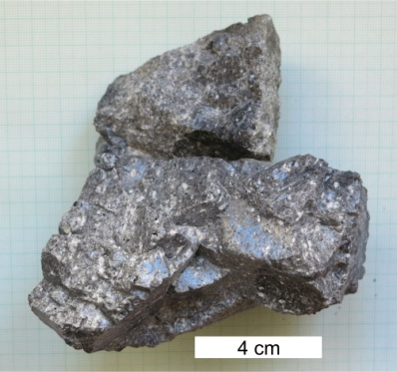 | 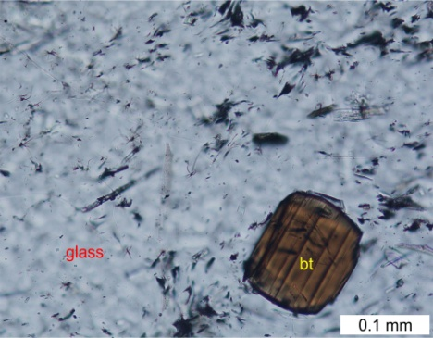 | 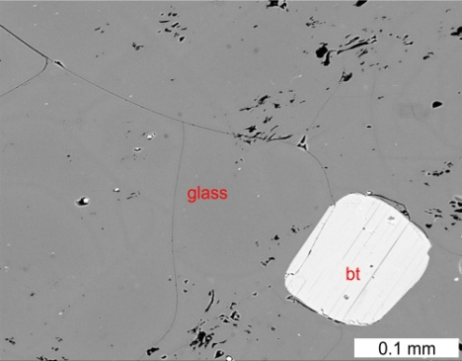
PL-19 (48 32 24.5N 18 48 32.1E): Dark dense perlite showing flow-banding – a piece from a block in the lava flow breccia in the western part of the deposit. Pores are almost absent.

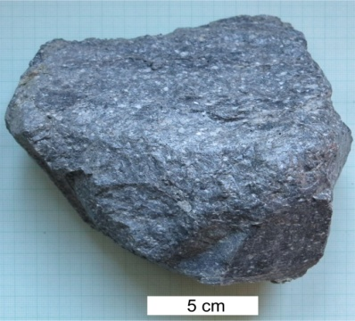 | 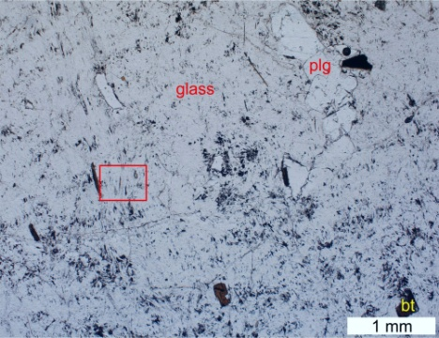 | Detail from microphoto on the left  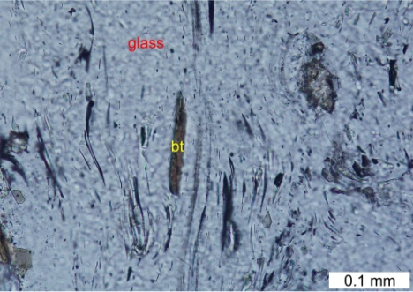
PL-20a (48 32 24.2N 18 48 32.8E): Dark dense perlite – a piece from a block in the exploited perlitic extrusive breccia, western part of the deposit. Detail shows extremely streched narrow pores.

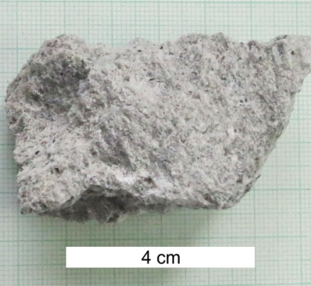 | 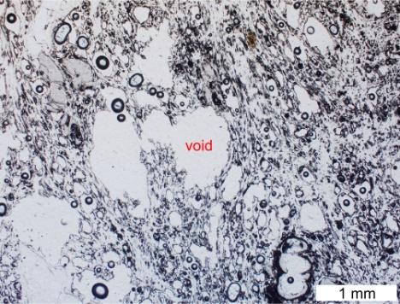 | 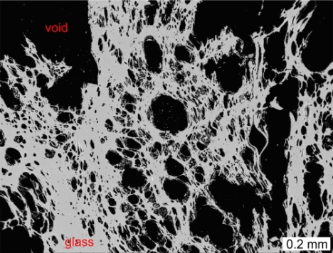
PL-22 (48 32 24.3N 18 48 38.5E): Pale grey pumiceous perlite fragment from the exploited perlitic extrusive breccia, western part of the deposit.

Macrophoto | Microphoto | BSE image of glass
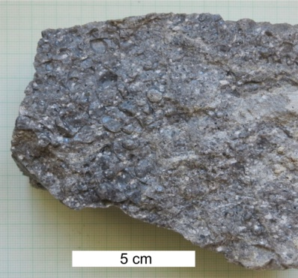 | 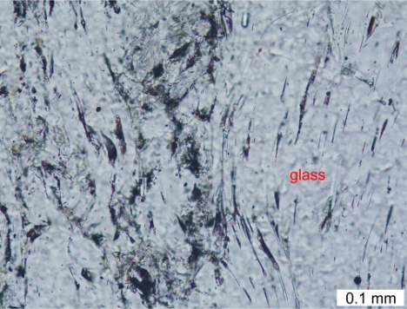 | 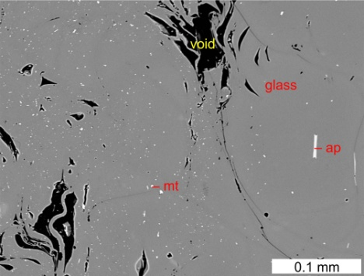
PL-24a (48 32 24.8N 18 48 39.4E): Dark dense perlite of coherent lava in the interior of a lava flow overlying the exploited perlitic extrusive breccia in the western part of the deposit.

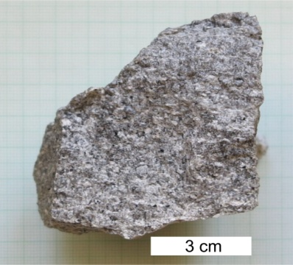 | 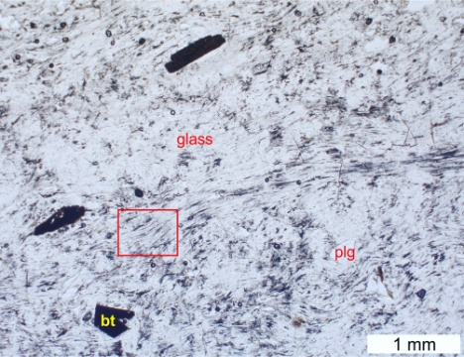 | Detail from microphoto on the left  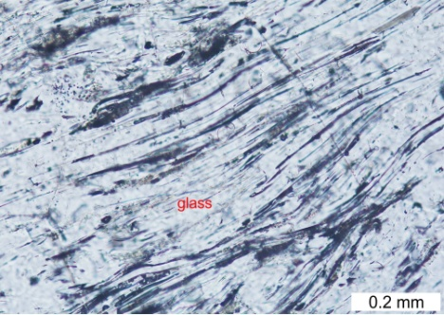
PL-24c (48 32 24.8N 18 48 39.4E): Grey perlite fragment in breccia of a lava flow overlying the exploited perlitic extrusive breccia in the western part of the deposit. Detail shows extremely stretched narrow pores.

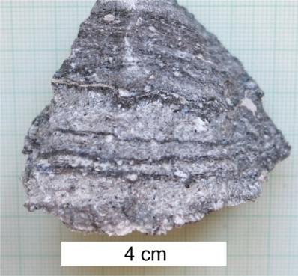 | 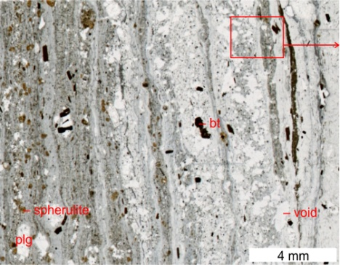 | 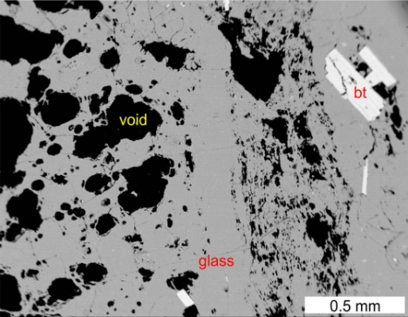
PL-24d (48 32 24.8N 18 48 39.4E): Perlite fragment showing flow banding in breccia of the lava flow overlying the exploited perlitic extrusive breccia in the western part of the deposit. Dark bands are dense, rich in microlites and tiny spherulites (brown). Pale bands are porous to pumiceous.

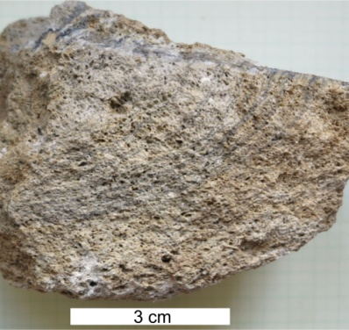 | 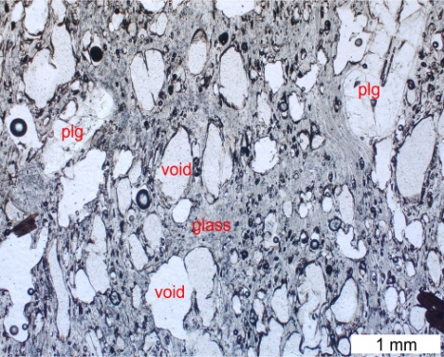 | 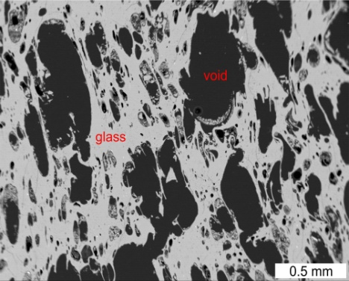
PL-24e3 (48 32 24.8N 18 48 39.4E): Vesicular perlite fragment in breccia of a lava flow overlying the exploited perlitic extrusive breccia in the western part of the deposit.

Macrophoto | Microphoto | BSE image of glass
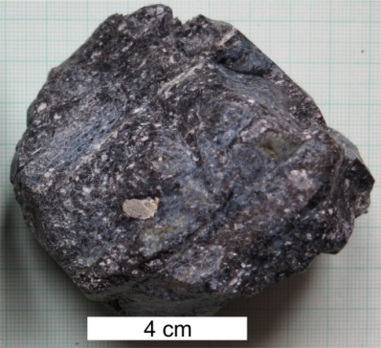 | 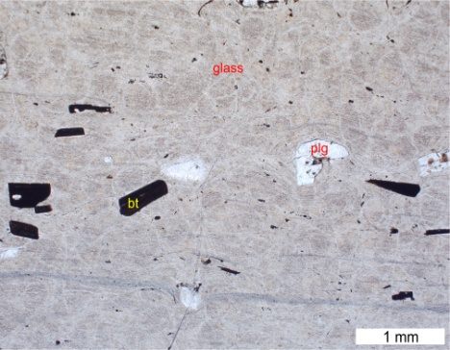 | 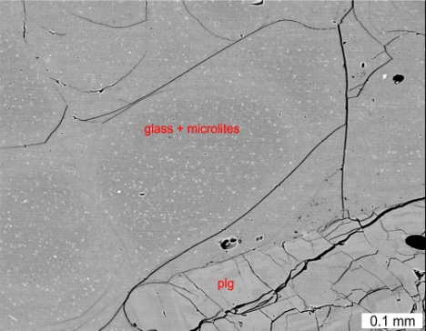
PL-29a (48 32 23.2N 18 48 34.4E): Dark dense perlite fragment in the perlitic extrusive breccia above the lava flow, western part of the deposit.

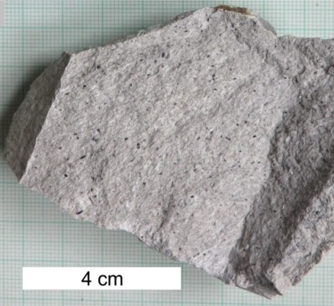 | 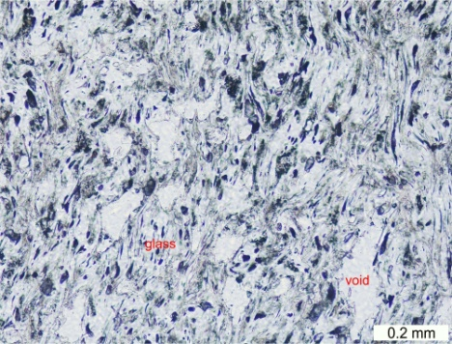 | 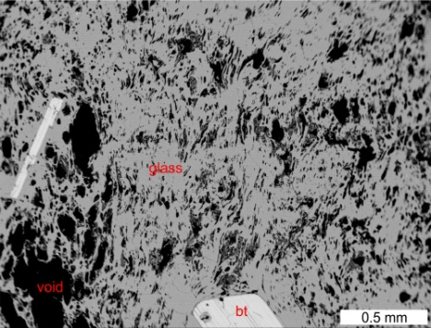
PL-29b (48 32 23.2N 18 48 34.4E): Pale grey porous perlite fragment in the perlitic extrusive breccia above the lava flow, western part of the deposit.

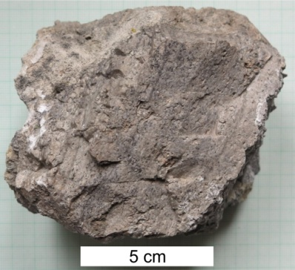 | 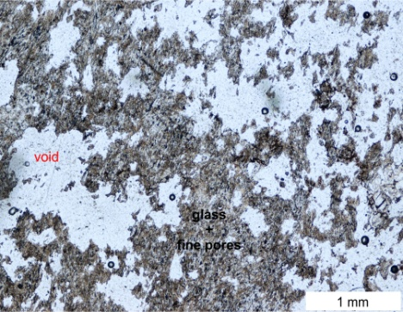 | Microphoto – detail of fine porous glass  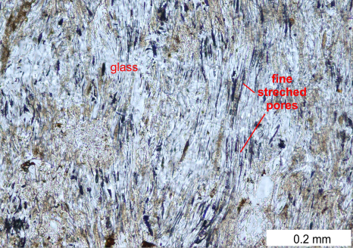
PL-72b1 (48 32 30.8N 18 49 33.2E): Pale grey pumiceous perlite angular fragment in the fine phreatomagmatic pyroclastic breccia 1 km east of the deposit.

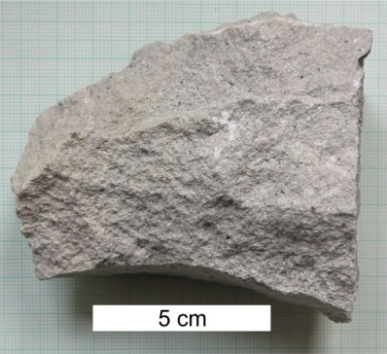 | 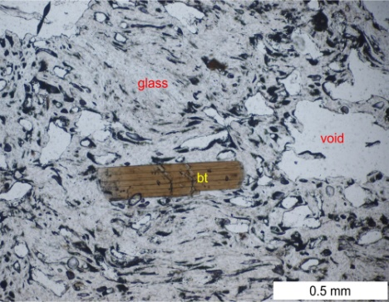 | 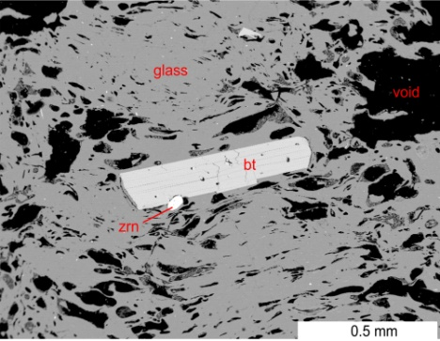
PL-91a1 (48 32 249.4N 18 48 45.2E): Pale grey porous perlite fragment from the exploited perlitic extrusive breccia, eastern part of the deposit.

Macrophoto | Microphoto | BSE image of glass
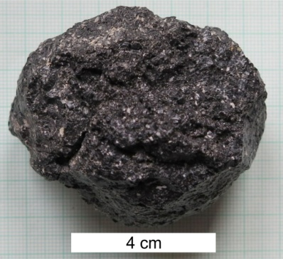 | 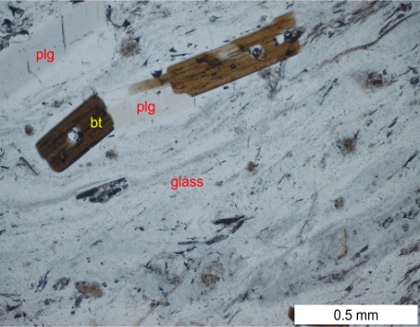 | 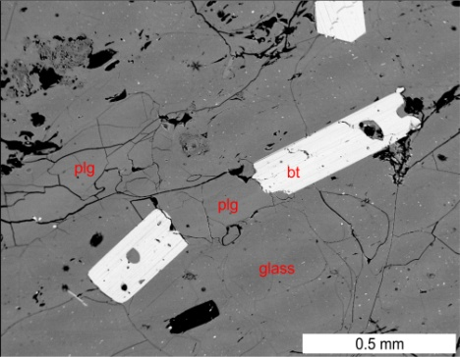
PL-91a3 (48 32 249.4N 18 48 45.2E): Dark dense perlite fragment from the exploited perlitic extrusive breccia, eastern part of the deposit.

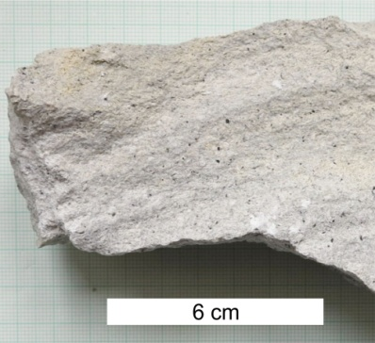 | 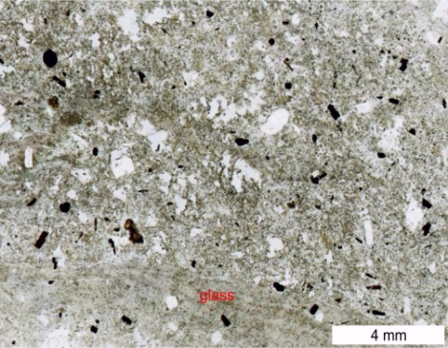 | 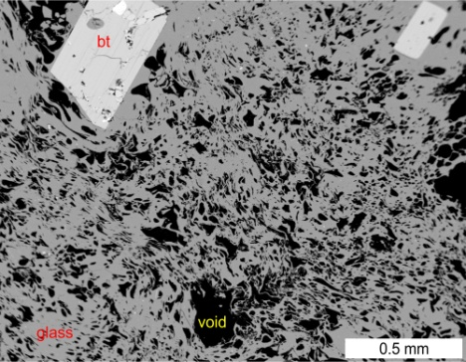
PL-93a (48 32 30.7N 18 48 45.9E): Pale grey porous perlite fragment from the exploited perlitic extrusive breccia, eastern part of the deposit.

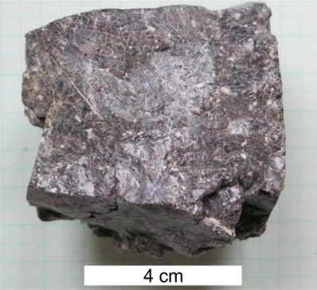 | 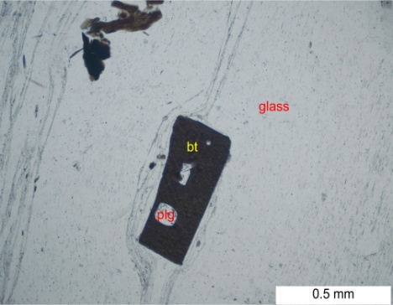 | 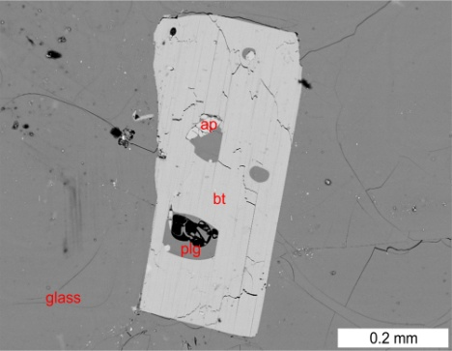
PL-93b (48 32 30.7N 18 48 45.9E): Dark dense perlite fragment from the exploited perlitic extrusive breccia, eastern part of the deposit.

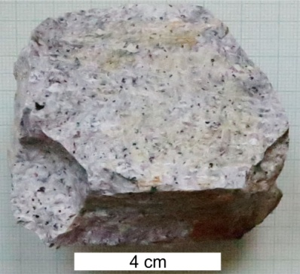 | 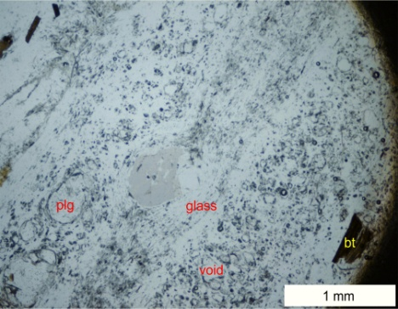 | 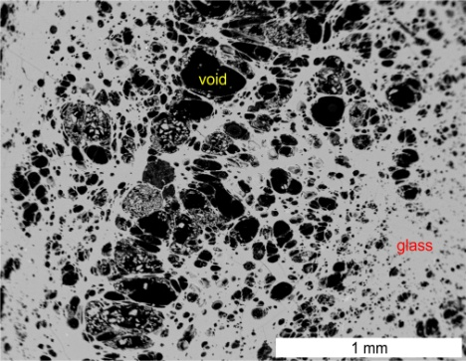
PL-95 (48 32 32.5N 18 48 44.5E): Grey porous perlite fragment in the phreatomagmatic pyroclastic breccia overlying perlitic extrusive breccia in the eastern pert of the deposit.

Macrophoto | Microphoto
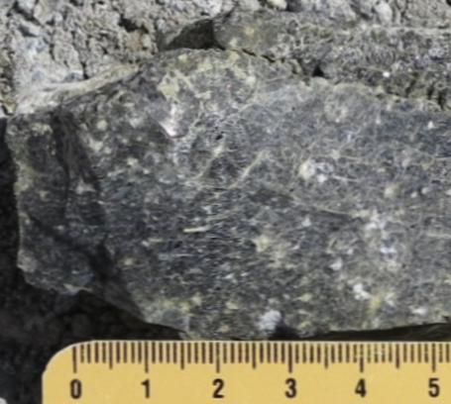 | 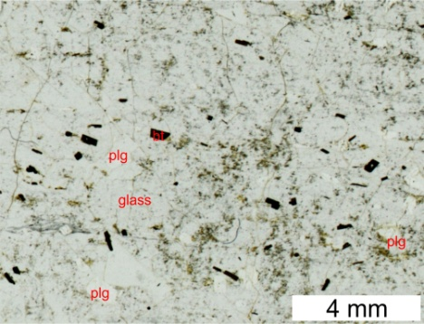 |  | Microphoto – detail of dense glass  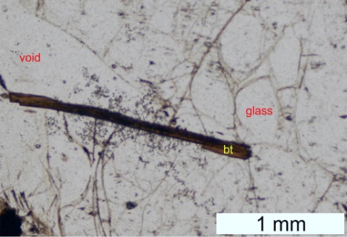
PL-134a (48 32 24.4N 18 48 38.8E): Dark dense perlite fragment in the exploited perlitic extrusive breccia, western part of the deposit.
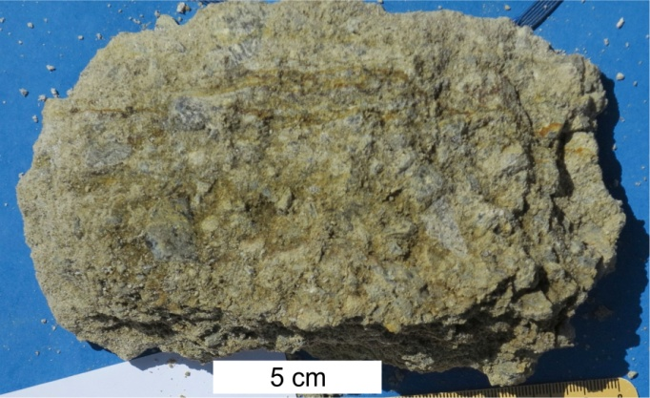 |  | <<< PL-134b  (48 32 24.4N 18 48 38.8E):  Matrix of the exploited perlitic extrusive breccia affected by argillic alteration, western part of the deposit.
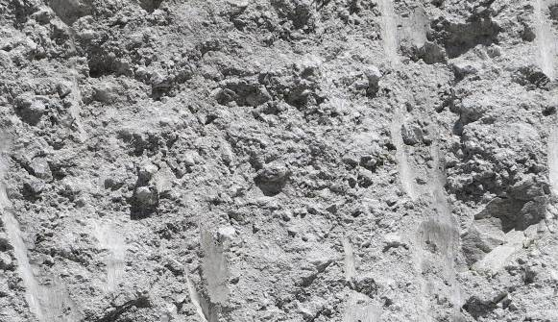 |  | <<< PL-134c (48 32 24.4N 18 48 38.8E): fresh unaltered matrix of the exploited perlitic extrusive breccia, western part of the deposit. It includes small fragments, pale grey porous perlite dominates. Width of the picture is 60 cm.
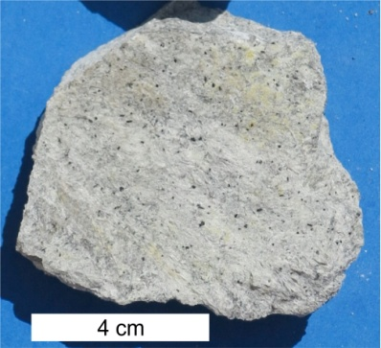 | 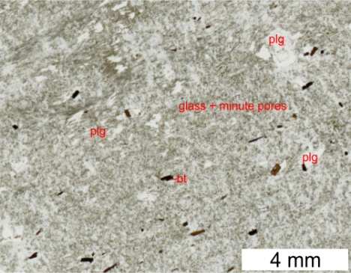 |  | Microphoto – detail of fine porous glass  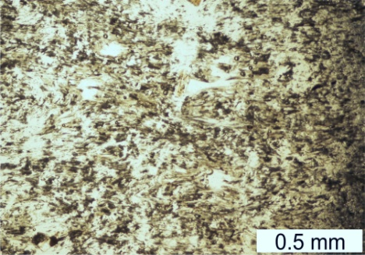
PL-134d (48 32 24.4N 18 48 38.8E): Pale grey porous perlite fragment from the exploited perlitic extrusive breccia, western part of the deposit.
PL-135c (48 32 24.4N 18 48 38.8E): No picture – fresh unaltered matrix of the exploited perlitic extrusive breccia, western part of the deposit. It includes small fragments, pale grey porous perlite dominates.

Macrophoto | Microphoto
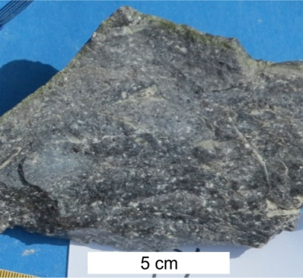 | 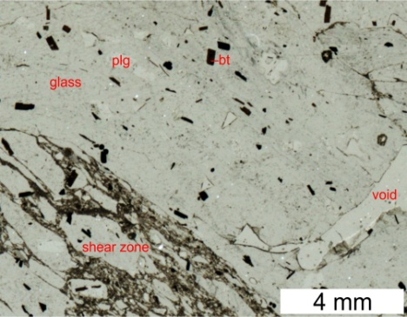 |  | <<< PL-136a  (48 32 24.7N 18 48 33.5E):  Dark dense perlite fragment in the exploited perlitic extrusive breccia underneath the lava flow, western part of the deposit.
PL-136c (48 32 24.7N 18 48 33.5E): No picture – fresh unaltered matrix of the exploited perlitic extrusive breccia underneath the lava flow, western part of the deposit. It is enriched in dark dense perlite.
Macrophoto | Microphoto
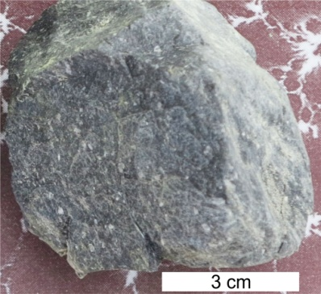 | 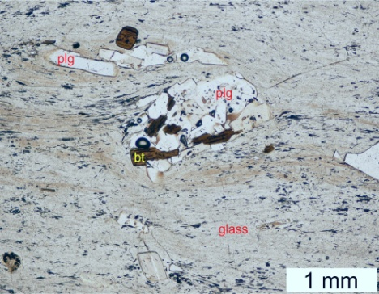 |  | Microphoto – detail of dense glass  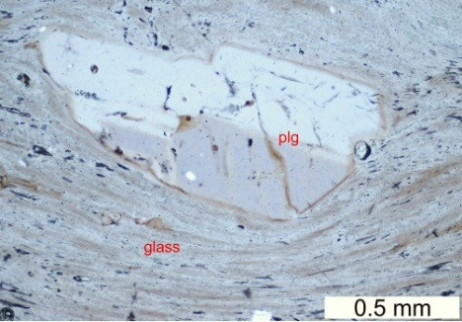
PL-140a (48 32 23,5N 18 48 36,9E): Dark dense perlite fragment in the perlitic extrusive breccia, eastern part of the deposit. Detail shows extremely stretched narrow pores.

Macrophoto | Microphoto |  | BSE image of glass |  | Microphoto
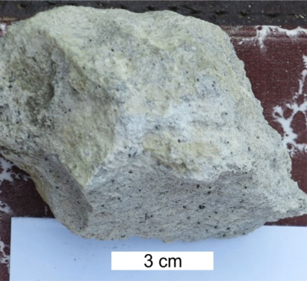 | 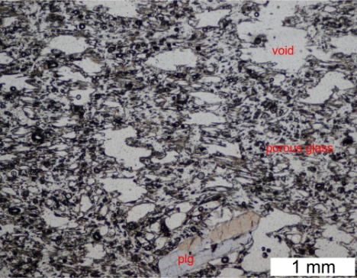 |  | 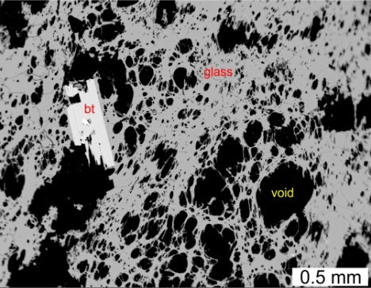
PL-140b (48 32 23,5N 18 48 36,9E): Pale grey porous perlite fragment in the perlitic extrusive breccia, eastern part of the deposit.
PL-140d (48 32 23.5N 18 48 36.9E): No picture – fresh unaltered matrix of the exploited perlitic extrusive breccia, western part of the deposit. It includes smal fragments, pale grey porous perlite dominates.
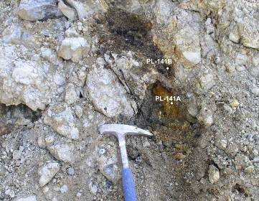 |  | <<< PL-141a,b (48 32 22,8N 18 48 38,8E): Rusty argillized perlite in the upper part of perlitic extrusive breccia in the western part of the deposit.

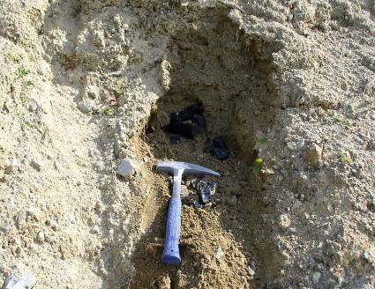 |  | <<< PL-143b (48 32 22.6N 18 48 40.3E): homogenized fine facies of the exploited perlitic extrusive breccia, western part of the deposit.
PL-144e (48 32 29.7N 18 48 45.5E): No picture – fresh unaltered matrix of the exploited perlitic extrusive breccia, eastern part of the deposit. It includes small fragments.
PL-148c (48 32 28.8N 18 48 42.4E): No picture – fresh unaltered matrix of the exploited perlitic extrusive breccia, eastern part of the deposit. It includes small fragments.
PL-150c (48 32 25.1N 18 48 33.7E): No picture – fresh unaltered matrix of the exploited perlitic extrusive breccia, western part of the deposit. It includes small fragments, pale grey porous perlite dominates.
PL-151c (48 32 25.0N 18 48 35.7E): No picture – fresh unaltered matrix of the exploited perlitic extrusive breccia, western part of the deposit. It includes small fragments, pale grey porous perlite dominates.
Macrophoto | Microphoto
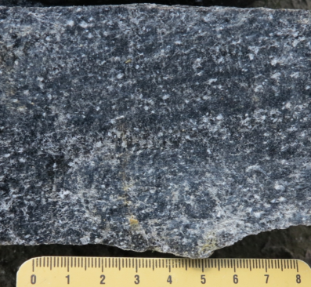 | 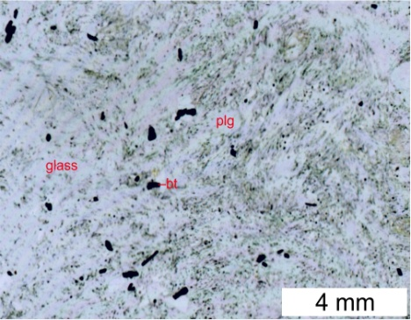 |  | <<< PL-241a  (48 32 31.6N 18 48 34.8E):  A piece of a large block of dark dense perlite in the phreatomagmatic breccia, the lowermost unit in the western part of the deposit.
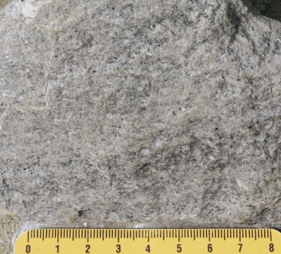 | 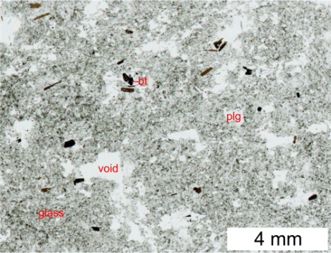 |  | <<< PL-241b  (48 32 31.6N 18 48 34.8E):  A piece of a large block of grey porous perlite in the phreatomagmatic breccia, the lowermost unit in the western part of the deposit.
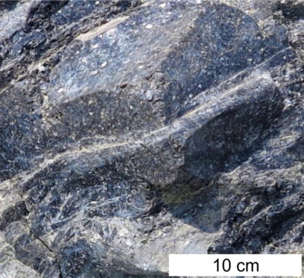 | 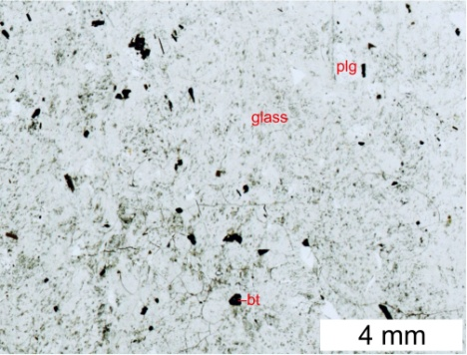 |  | <<< PL-242  (48 32 25.4N 18 48 31.8E):  Dark dense perlite – a piece of a large block in the breccia at the base of the lava flow, western part of the deposit.

Macrophoto | Microphoto | BSE image of glass
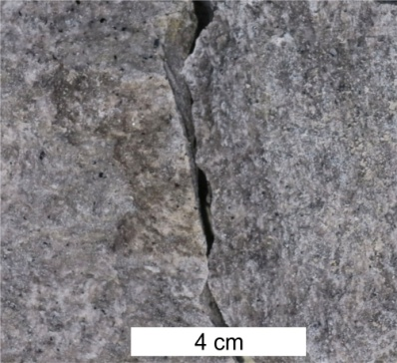 | 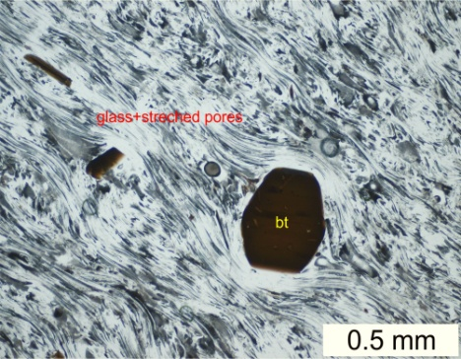 | 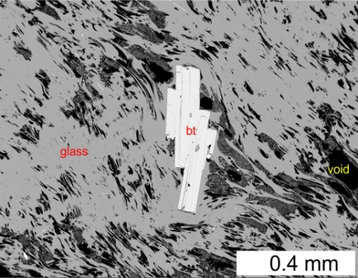
PL-244 (48 32 25.0N 18 48 36.1E): A piece of a large block of grey porous perlite in the exploited perlitic extrusive breccia, western part of the deposit.
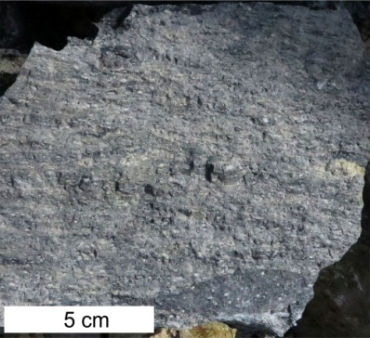 | 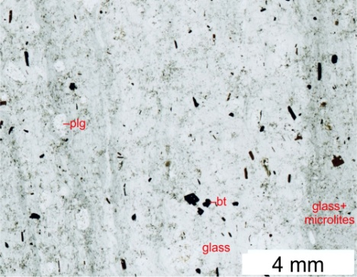 | 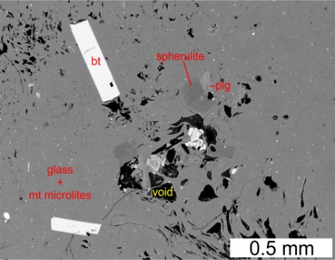
PL-248a (48 32 24.5N 18 4839.6E): Dark perlite of a lava flow showing flow banding and eutaxitic texture, western part of the deposit.
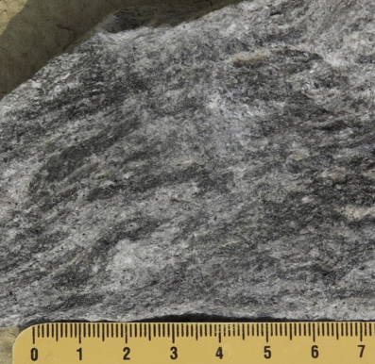 | 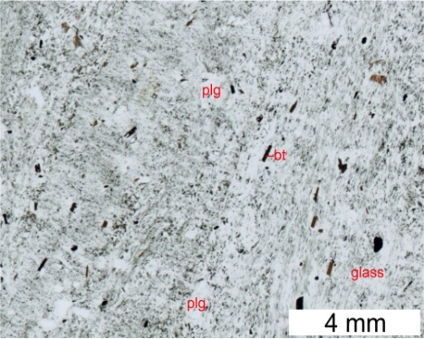 | <<< PL-254  (48 32 23.9N 18 48 35.2E):  Dark perlite of a lava flow breccia showing flow banding and eutaxitic texture, western part of the deposit.
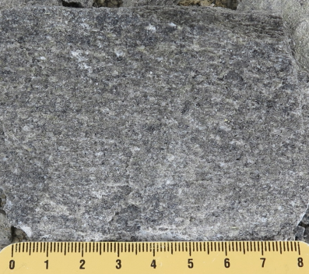 | 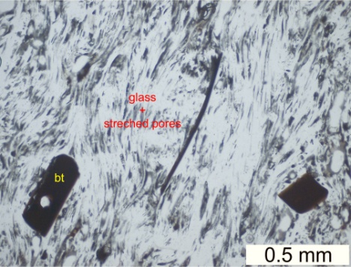 | 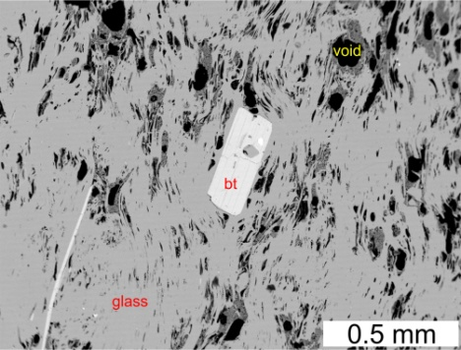
PL-255 (48 32 23.6N 18 48 35.6E): A piece of a large block of grey porous perlite showing flow orientation in the exploited perlitic extrusive breccia, western part of the deposit.
Macrophoto | Microphoto | BSE image of glass
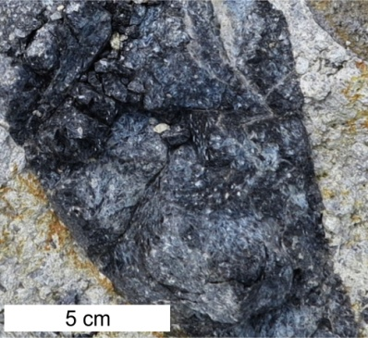 | 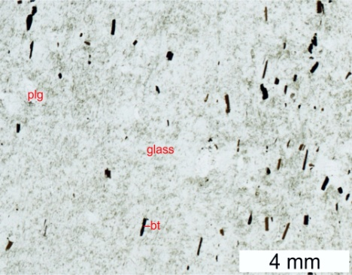 | <<< PL-263a  (48 32 23.0N 18 48 37.0E):  Dark dense perlite fragment in lava flow breccia, western part of the deposit.
1b.The Lehôtka pod Brehmi rhyolite monogenetic volcano –
Szabóova skala cryptodome west of the perlite deposit
Macrophoto | Microphoto | BSE image of glass
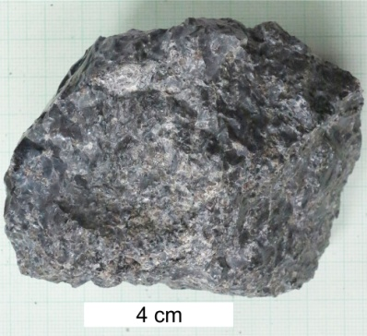 | 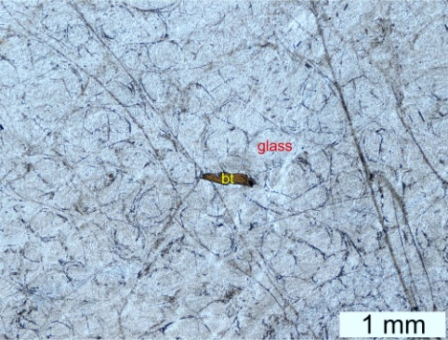 | 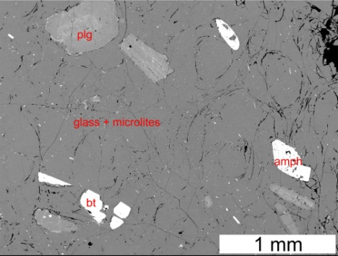
PH-16 (48 32 10.6N 18 48 33.3E): Dark dense perlite – a piece from a massive perlitic glassy margin of the cryptodome.

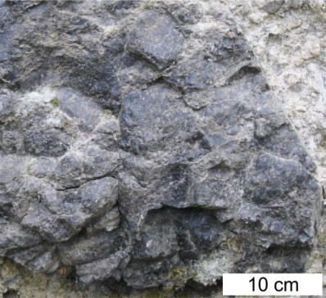 | 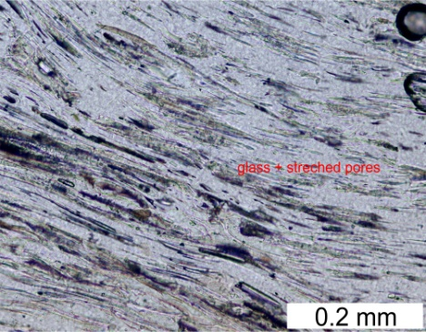 | 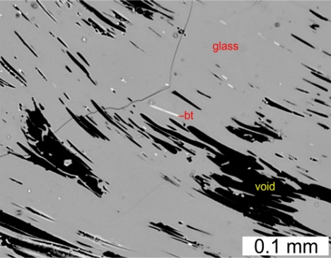
SS-1 (48 32 15.3N 18 48 17.5E): Dark dense perlite – a piece from a block in extrusive perlitic breccia next to the cryptodome. BSE image shows extremely stretched narrow pores.

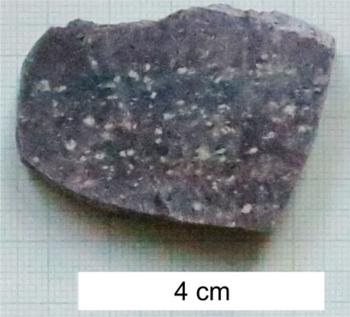 | 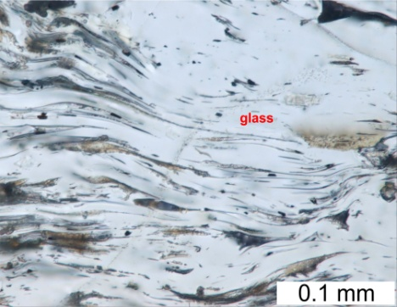 | 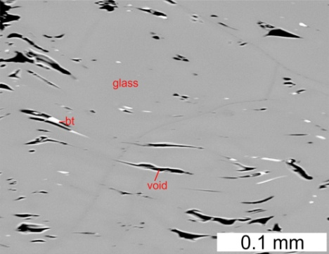
SS-1a (48 32 15.3N 18 48 17.5E): Dark dense perlite – a piece from a block in extrusive perlitic breccia next to the cryptodome.

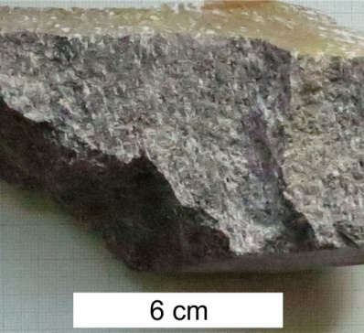 | 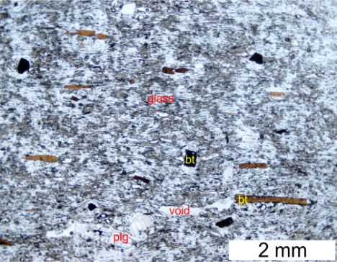 | 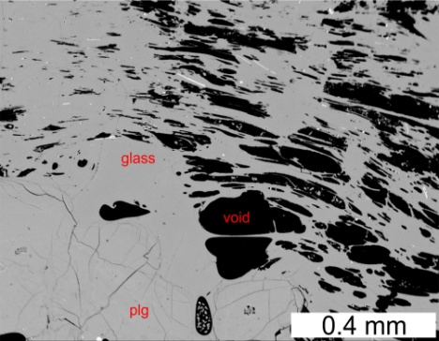
SS-1b (48 32 15.3N 18 48 17.5E): Grey porous perlite – a piece from a block in extrusive perlitic breccia next to the cryptodome.

Macrophoto | Microphoto | BSE image of glass
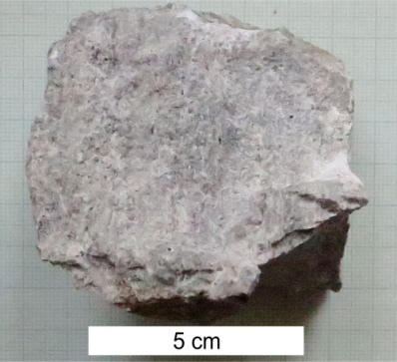 | 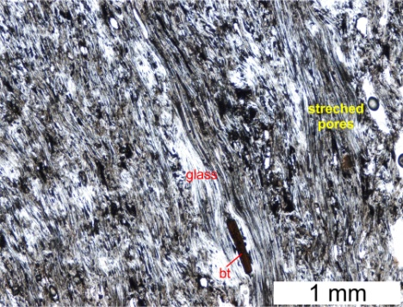 | 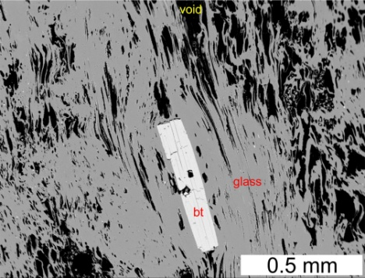
SS-1c (48 32 15.3N 18 48 17.5E): Pale grey porous perlite showing flow banding – a piece from a block in extrusive perlitic breccia next to the cryptodome.

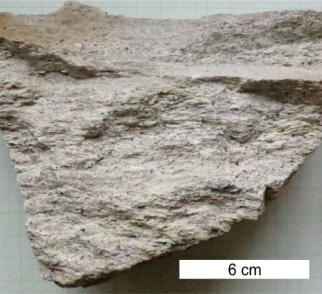 | 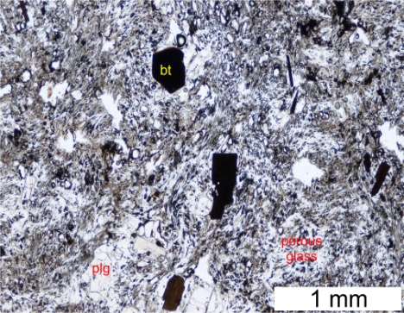 | 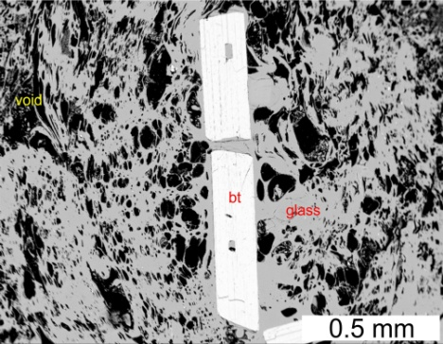
SS-1d (48 32 15.3N 18 48 17.5E): Pale grey pumiceous perlite – a piece from a block in extrusive perlitic breccia next to the cryptodome.

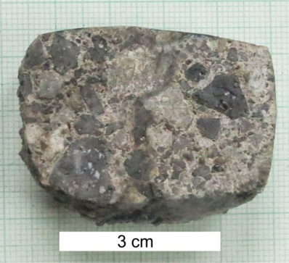 | 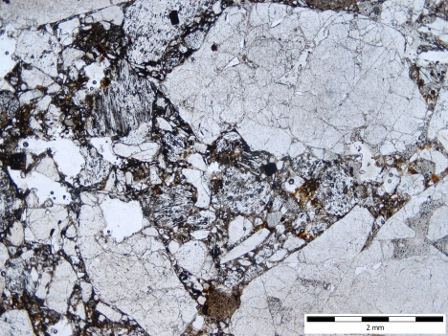 | 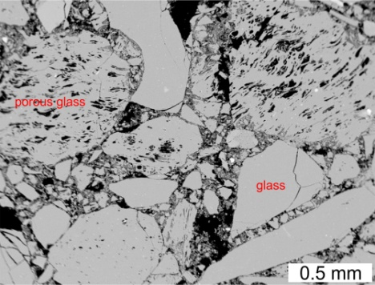
SS-2 (48 32 11.2N 18 48 16.7E): Matrix of perlitic hyaloclastite breccia at the margin of the cryptodome. Both, dense and porous glass fragments are present.

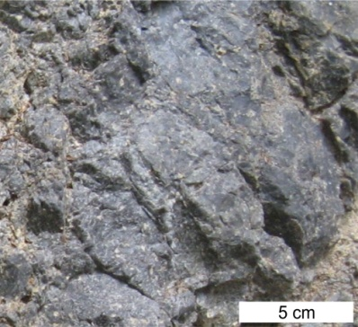 | 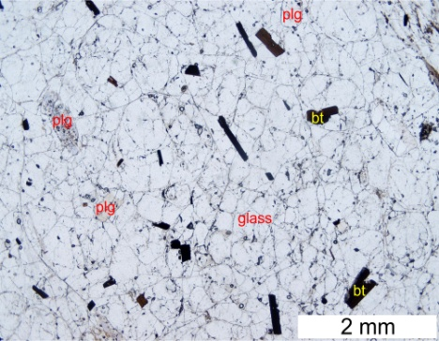 | 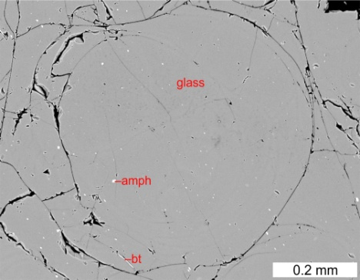
SS-3 (48 32 09.8N 18 48 21.6E): Dark dense perlite – a piece from a massive perlitic glassy margin of the cryptodome, A rare example of a pearl-like disintegration.

Macrophoto | Microphoto | BSE image of glass
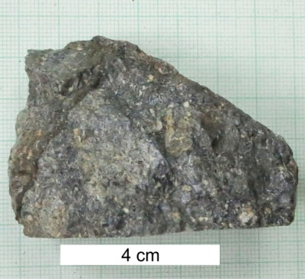 | 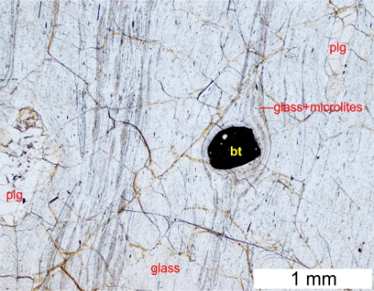 | 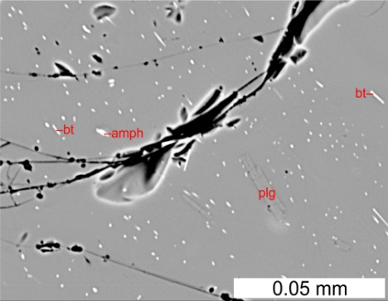
SS-3b (48 32 09.8N 18 48 21.6E): Dark dense perlite – a piece from a massive perlitic glassy margin of the cryptodome. Microlites concentrate in dark bands.

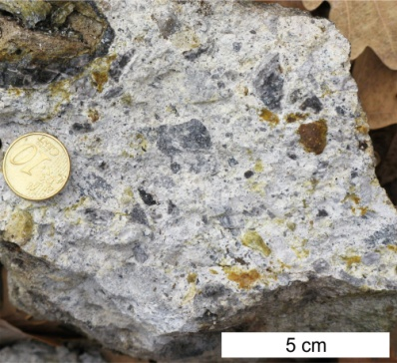 | 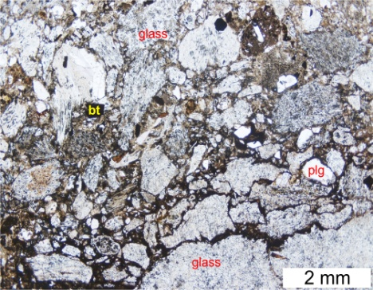 | 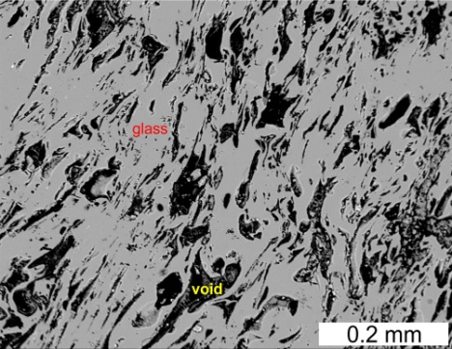
SS-5a (48 32 11.7N 18 48 25.5E): Matrix of hyaloclastite breccia at the margin of the cryptodome. Fragments show a variable porosity.

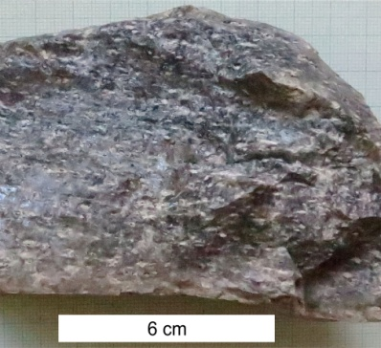 | 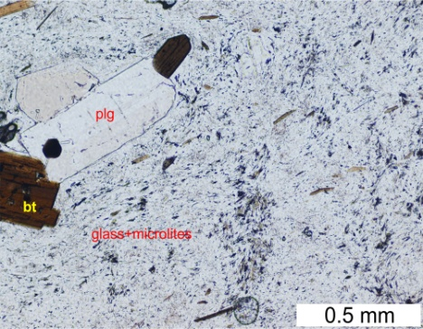 | 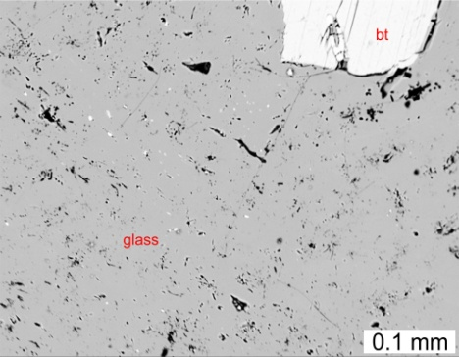
SS-5b (48 32 11.7N 18 48 25.5E): Dark dense perlite fragment in hyaloclastite breccia at the margin of the cryptodome. Note a low porosity.

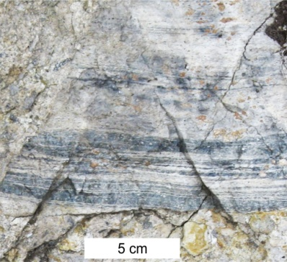 | 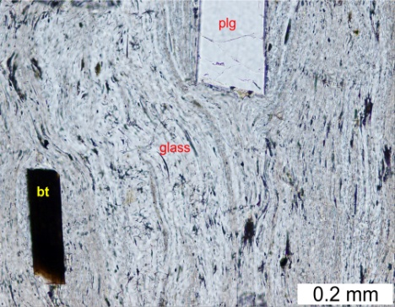 | 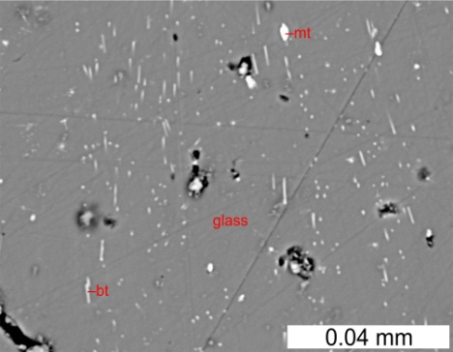
SS-5c (48 32 11.7N 18 48 25.5E): Grey perlite fragment showing flow banding; hyaloclastite breccia at the margin of the cryptodome. Microlites concentrate in dark bands.

1.The Jastrabá perlite deposit (rhyolite monogenetic volcano)
Macrophoto | Microphoto |  | BSE image of glass
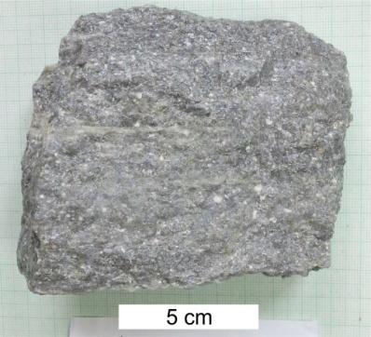 | 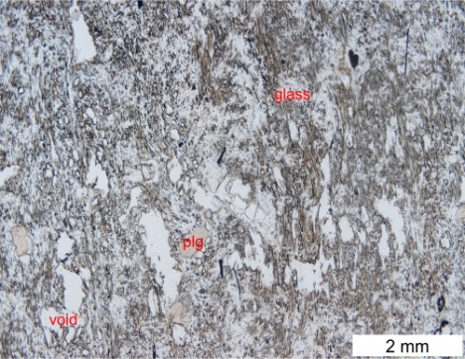 |  | 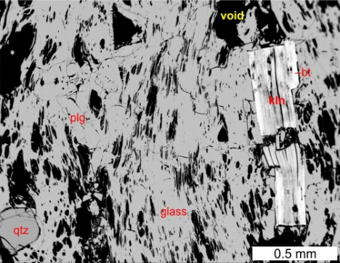
JA-6 (48 38 32.08N 18 55 43.5E): Grey moderately porous perlite showing flow banding – a piece from a large block in block and ash pyroclastic flow deposits, 600 m ENE of the deposit.
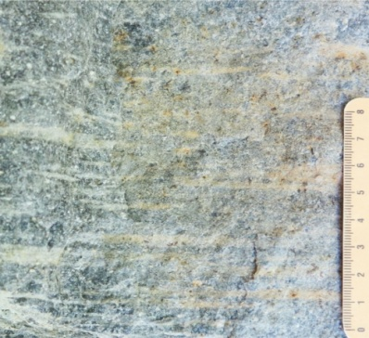 | 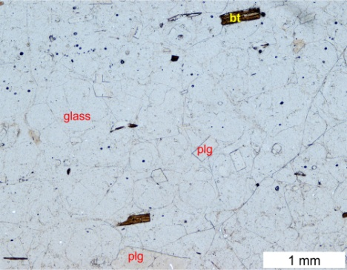 |  | 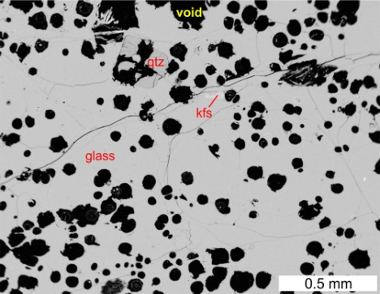
JA-6a (48 38 32.08N 18 55 43.5E): Grey moderately porous perlite showing flow banding – a piece from a large block in block and ash pyroclastic flow deposits, 600 m ENE of the deposit. BSE image shows a rare case of undeformed pores.
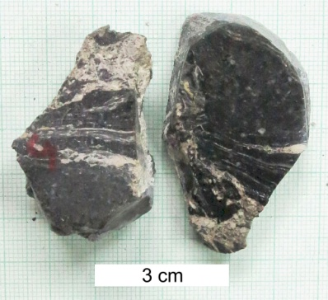 | 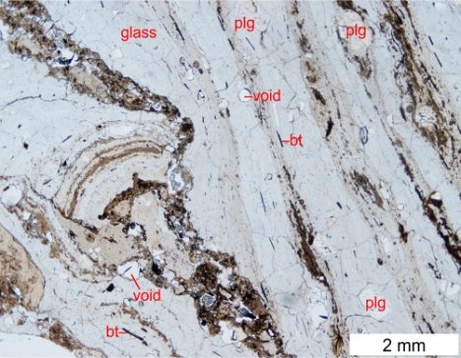 |  | 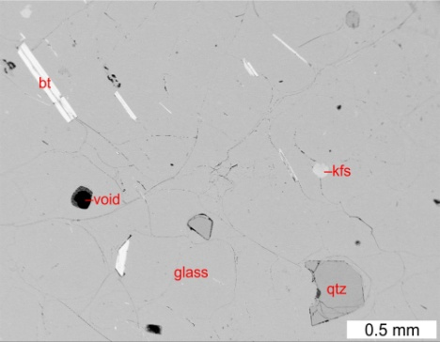
JA-6b (48 38 32.08N 18 55 43.5E): Dark dense perlite fragment in block and ash pyroclastic flow deposits, 600 m ENE of the deposit.
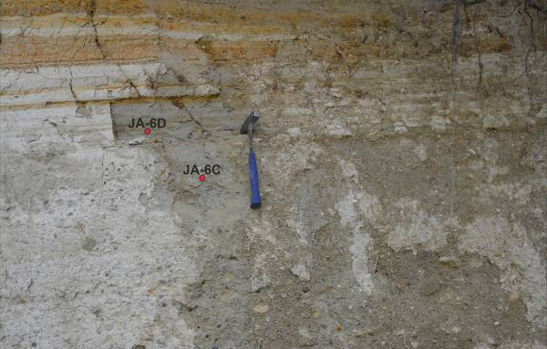 |  | 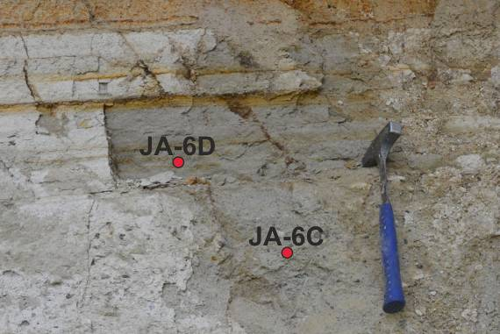
JA-6c a JA-6d (48 38 32.08N 18 55 43.5E): JA-6c – matrix of block and ash pyroclastic flow deposits, JA-6d – sorted fall tuff overlying block and ash pyroclastic flow deposits 600 m ENE of the deposit.

Macrophoto | Microphoto | BSE image of glass
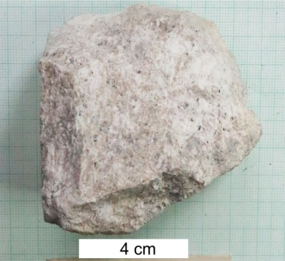 | 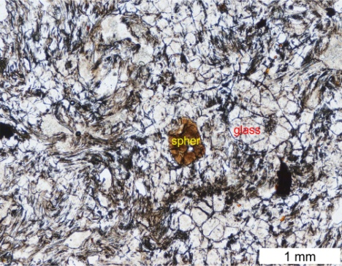 | 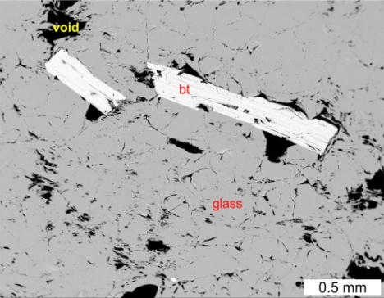
JS-2 (48 38 15.8N 18 55 15.8E): Grey to pinkish-grey, spalely porous fragment in the extrusive breccia, southern part of the deposit.
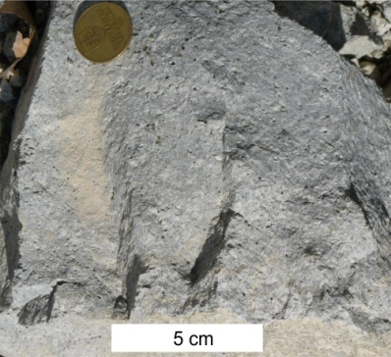 | 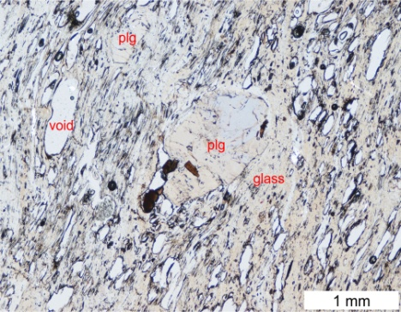 | 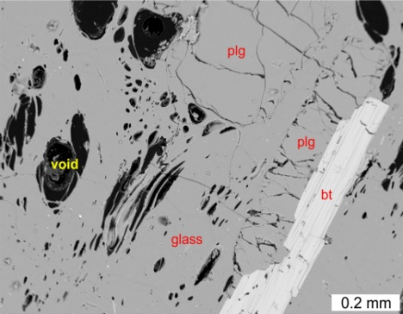
JS-4 (48 38 27.1N 18 55 15.2E): Grey porous perlite – a piece from a chilled block with radial jointing in the perlitic extrusive breccia, central part of the deposit.
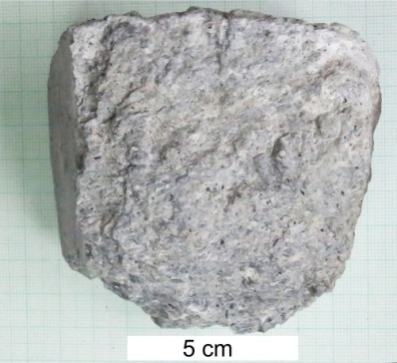 | 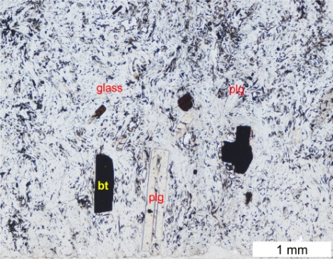 | 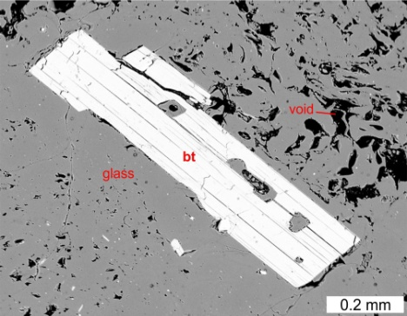
JS-5 (48 38 22.5N 18 55 17.4E): Grey moderately porous perlite from a glassy margin of the coulée, roof of the deposit.
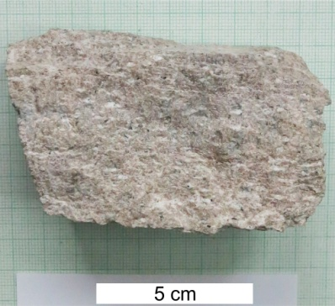 | 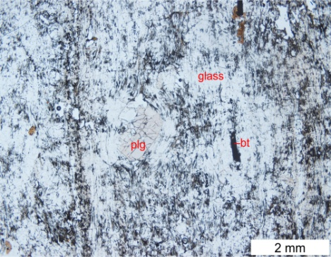 | Microphoto – detail of dense glass  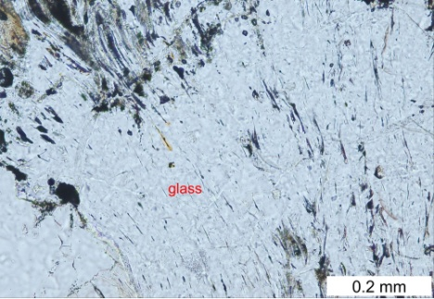
JS-21a (48 38 15.8N 18 55 15.8E): Pinkish-grey, slightly porous fragment in extrusive breccia showing flow orientation, southern part of the deposit.

Macrophoto | Microphoto | BSE image of glass
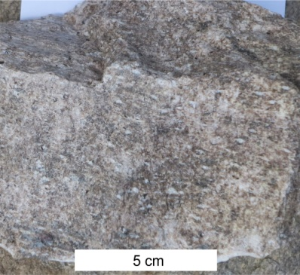 | 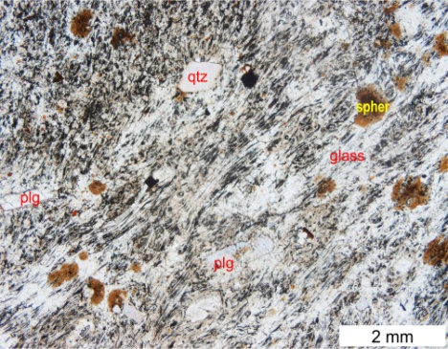 | 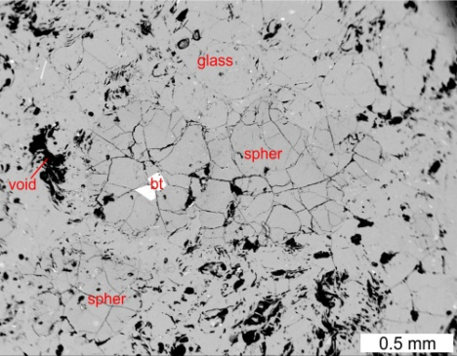
JS-21b (48 38 15.8N 18 55 15.8E): Grey, slightly porous fragment in the extrusive breccia showing flow orientation, southern part of the deposit. This sample of perlite includes subordinate spherulites.

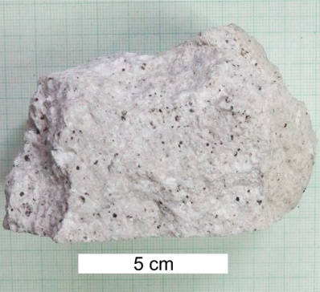 | 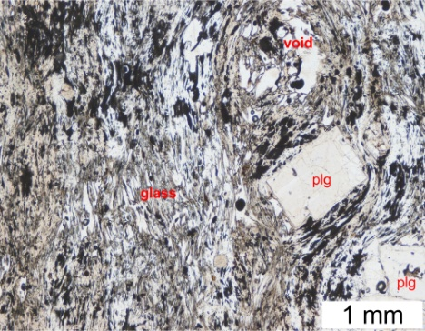 | 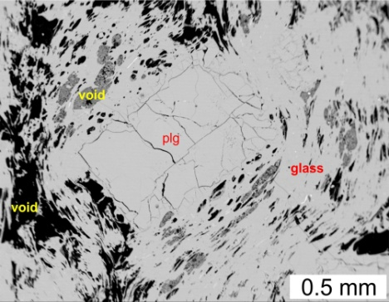
JS-22 (48 38 27.1N 18 55 15.2E): Grey porous perlite – a piece from a chilled block with radial jointing in the perlitic extrusive breccia, central part of the deposit.

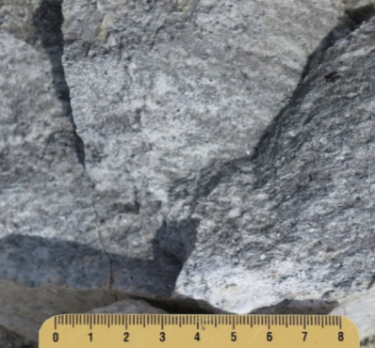 | 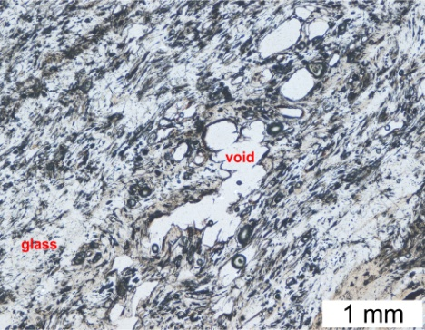 | 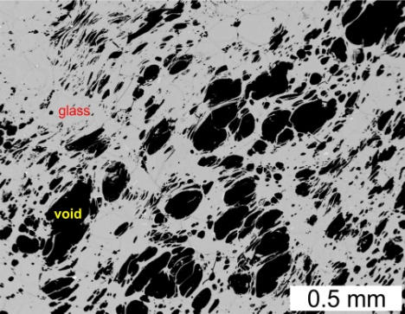
JS-22c (48 38 27.1N 18 55 15.2E): Grey porous perlite – a piece from a block showing incipient flow-banding in the perlitic extrusive breccia, central part of the deposit.

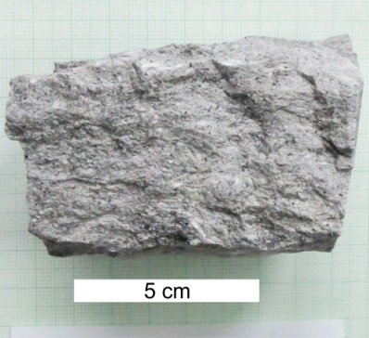 | 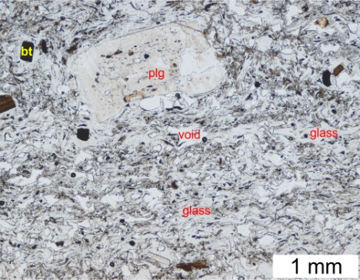 | 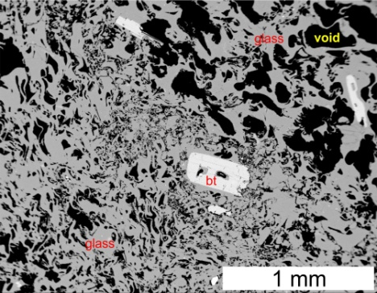
JS-24 (48 38 22.5N 18 55 17.4E): Grey porous to pumiceous perlite from a glassy margin of the coulée, roof of the deposit.

Macrophoto | Microphoto | BSE image of glass
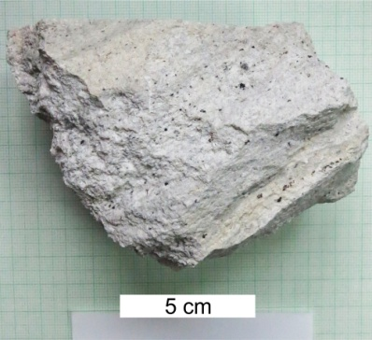 | 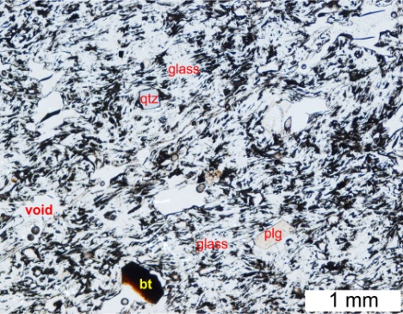 | 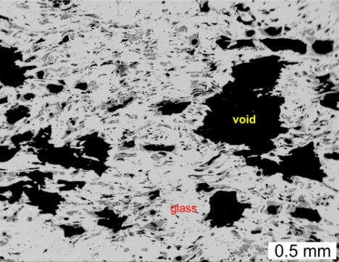
JS-25 (48 38 27.1N 18 55 15.2E): Pale grey porous perlite showing incipient flow-banding – an angular fragment in the perlitic extrusive breccia, central part of the deposit.

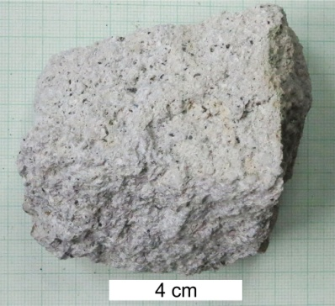 | 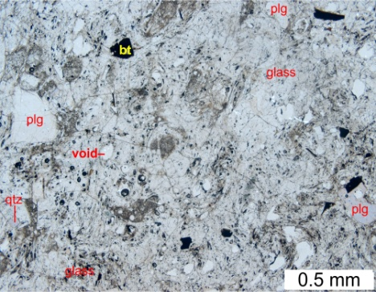 | 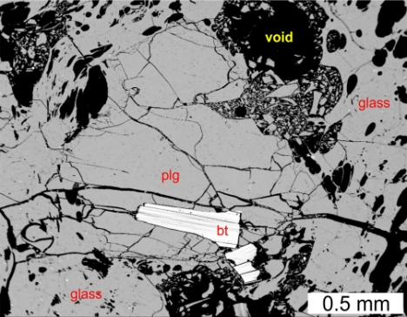
JS-26 (48 38 27.1N 18 55 15.2E): Pale grey porous perlite – a fragment in the perlitic extrusive breccia, central part of the deposit.
JS-26a (48 38 27.1N 18 55 15.2E): No picture – unaltered granular matrix of the perlitic extrusive breccia, uncovered part of the deposit. It includes small fragments.
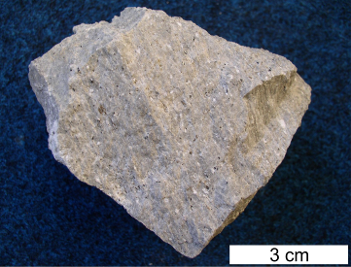 | <<< JS-26b (48 38 27.1N 18 55 15.2E): Pale grey porous perlite, a fragment in the perlitic extrusive breccia, uncovered part of the deposit.
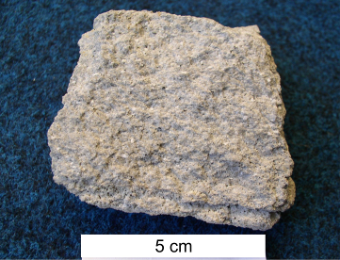 | <<< JS-26c (48 38 27.1N 18 55 15.2E): pale grey porous perlite, a fragment in the perlitic extrusive breccia, uncovered part of the deposit.
JS-26d (48 38 27.1N 18 55 15.2E): No picture – fragments of pale grey porous perlite in the perlitic extrusive breccia, uncovered part of the deposit.
JS-26e (48 38 27.1N 18 55 15.2E): No picture – unaltered granular matrix of the perlitic extrusive breccia, uncovered part of the deposit. It includes small fragments.

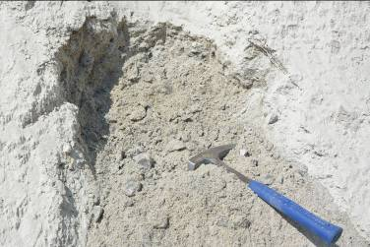 | <<< JS-26f (48 38 27.1N 18 55 15.2E): Unaltered grained matrix of the perlitic extrusive breccia, uncovered part of the deposit. It includes small fragments.
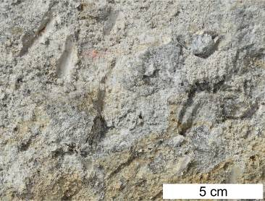 | <<< JS-27a (48 38 27.5N 18 55 15.1E): Grey crumbling perlite with small fragments in granular matrix, part of the perlitic extrusive breccia, uncovered part of the deposit.
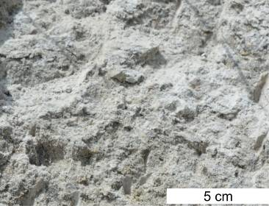 | <<< JS-27b (48 38 27.5N 18 55 15.1E): Grey crumbling perlite with small fragments in granular matrix, part of the perlitic extrusive breccia, uncovered part of the deposit.
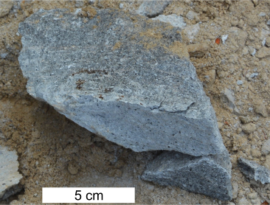 | <<< JS-28a (48 38 26.0N 18 55 15.5E): Dark grey perlite, a piece from a block at partly weathered surface, uncovered part of the deposit.
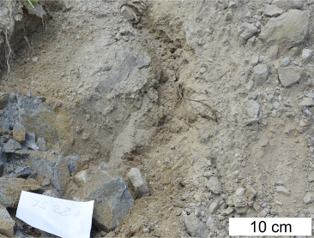 | <<< JS-28b (48 38 26.0N 18 55 15.5E): Ochre brown saprolite around the block of dark grey perlite.
 | Microphoto
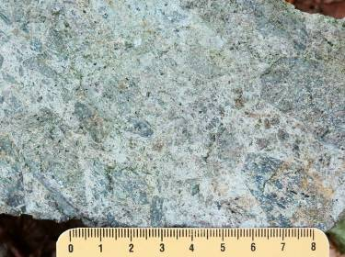 | 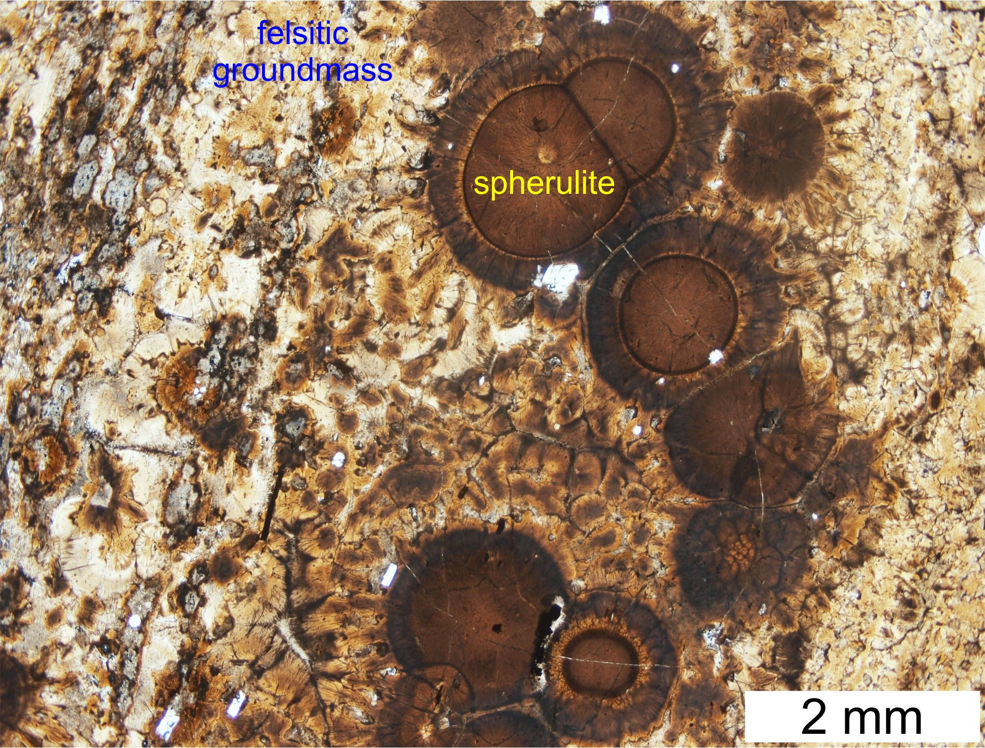 | <<< JS-31 (48 38 33.4N 18 55 10.51E): Pale brecciated felso-spherulitic rhyolite at the edge of a coulée NW of the deposit.

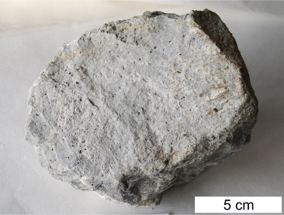 | <<< JS-32a (48 38 27.1N 18 55 15.2E): Pale grey porous perlite fragment from the perlitic extrusive breccia; collected from 1000 tonnes mined as technological testing sample at the uncovered part of the deposit in the year 2015.
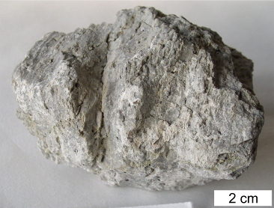 | <<< JS-32b (48 38 27.1N 18 55 15.2E): Pale grey porous perlite fragment from the perlitic extrusive breccia; collected from 1000 tonnes mined as technological testing sample at the uncovered part of the deposit in the year 2015.
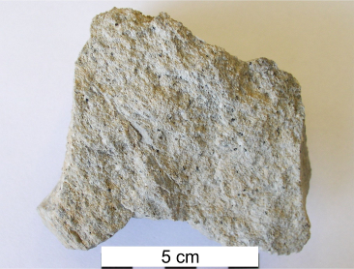 | <<< JS-32c (48 38 27.1N 18 55 15.2E): Pale grey porous perlite fragment from the perlitic extrusive breccia; collected from 1000 tonnes mined as technological testing sample at the uncovered part of the deposit in the year 2015.
Microphoto
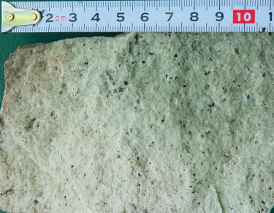 | 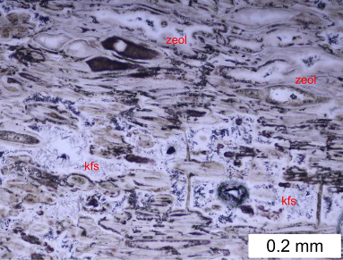 | <<< JS-36: (48 38 46.2N 18 54 47.1E): Fragment of porous greenish glassy rhyolite from zeolitised epiclastic volcanic breccia; an older unit of the Jastrabá Fm. underlying the Jastrabá volcano extrusive dome at the west.
BSE image
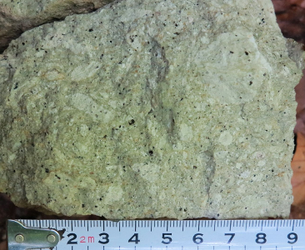 | 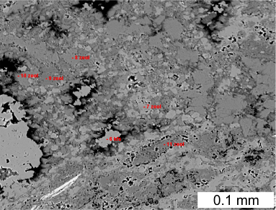 | <<< JS-40: (48 38 35.3N 18 54 51.8E): Zeolitised glassy rhyolite breccia at the margin of a cryptodome; an older unit of the Jastrabá Fm. underlying the Jastrabá volcano extrusive dome at the west.
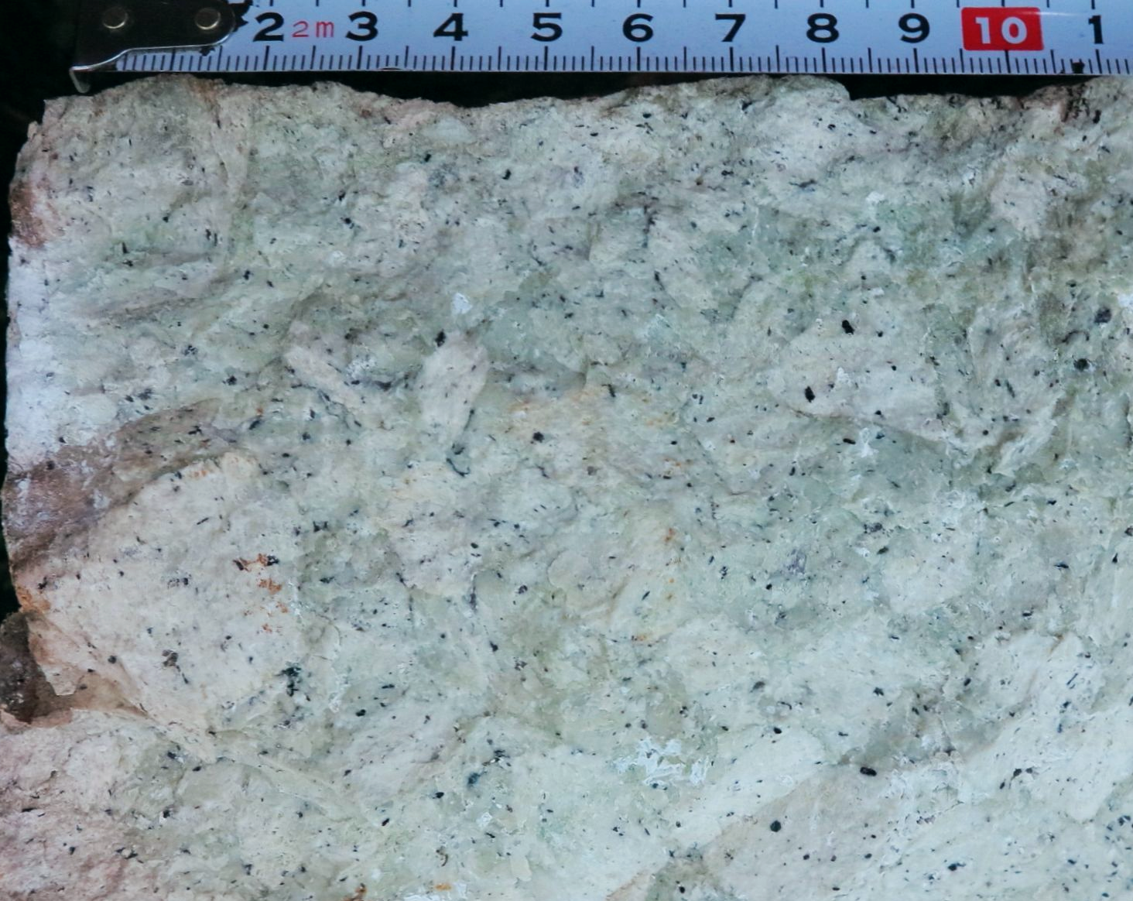 | <<< JS-42: (48 38 34.4N 18 54 45.5E): Zeolitised perlitic breccia at the margin of a cryptodome; an older unit of the Jastrabá Fm. underlying the Jastrabá volcano extrusive dome at the west.

