Perlite deposits of the Central Slovakia Volcanic Field (Western Carpathians): Geology and properties
Electronic supplement 2: field documentation and lithology
The Lehôtka pod Brehmi perlite deposit (rhyolite monogenetic volcano)
Rhyolite monogenetic volcano that hosts the LPB perlite deposit shows a complex structure and evolution at two volcanic centers. Phreatomagmatic tuffs and fine pyroclastic breccias rich in andesite fragments/pebbles represent the oldest, unexposed unit (known from boreholes) that rests on older andesites (Beňo & Očenáš 1962) and sediments of the Žiar basin (Forgáč et al. 1974). Poorly sorted tuffs and fine breccias are composed of angular fragments/grains of mostly porous perlitic rhyolite glass and subordinate subangular to suboval fragments/grains of various andesites in matrix of fine detritus.
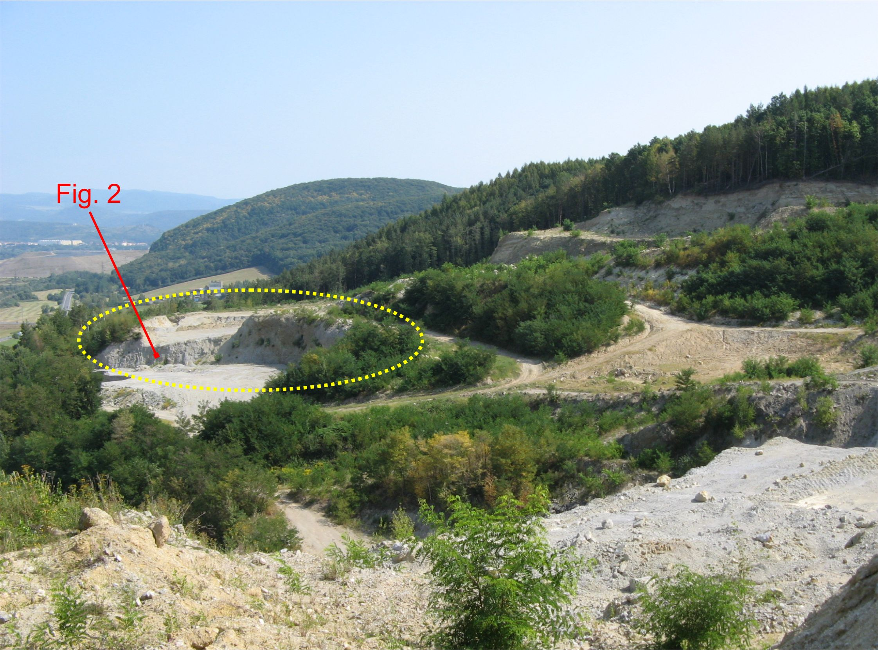 | 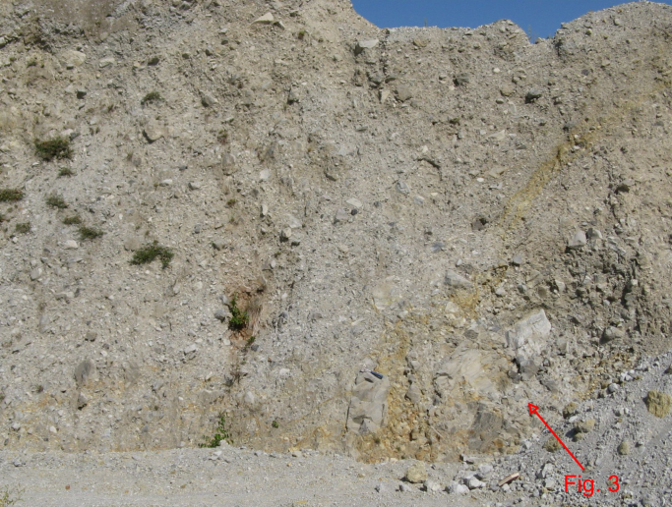
Fig. S1. Eastern part of the deposit (yellow dotted line). | Fig. S2. Perlitic extrusive breccia at the eastern part of the deposit (PL-41)
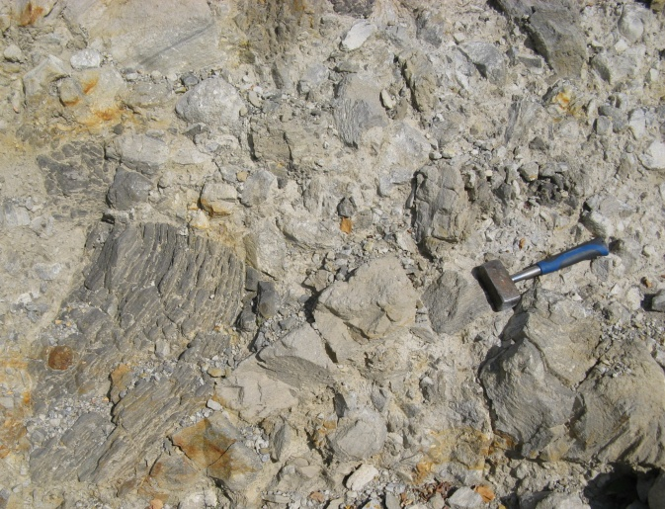 | 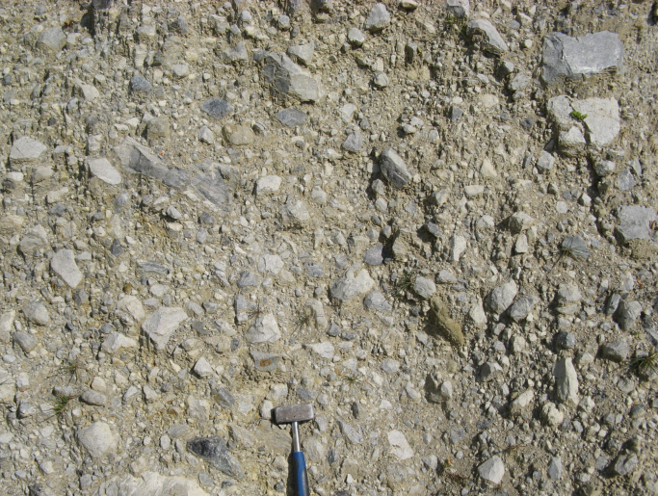
Fig. S3. Detail of the perlitic extrusive breccia at the eastern part of the deposit (PL-41) | Fig. S4. Detail of perlitic extrusive breccia at the eastern part of the deposit (PL-42).
In the eastern part of the deposit, a dome formed of extruded hyaloclastite breccia represents the overlying unit (Fig. S1). The chaotic breccia is mostly coarse, with angular fragments and blocks of grey to pale grey porous perlitic rhyolite glass, showing variably banded structure (Figs. S2–S4). Rarely there are present fragments of dark grey to black rhyolite glass. Maximum size of blocks is 60 cm, most of the fragments falls in the range 5 – 20 cm. Fine detritic matrix represents 10 – 20 % only. Generally, the breccia is matrix poor, showing a transition from the clast-supported to the matrix- supported structure.
Succession of the monogenetic volcano units continues in its western part and surroundings by a thick unit of phreatomagmatic tuffs and fine pyroclastic breccias (Fig. S6) with a lesser or rare admixtures of andesite and nonvolcanic rock pebbles. Fine breccias and lapilli tuffs with rare blocks dominate in the proximal facies that forms remnants of a pyroclastic ring (Figs. S7–S10). The pyroclastic deposits show a poor to moderate sorting, massive beds of breccia alternate with lapilli tuffs showing planar bedding. Rare impact structures of fragments and blocks have been observed too. Juvenile fragments of perlitic rhyolite glass are angular, often of the polygonal form with curviplanar edges. Blocks show sometimes radial jointing and disintegration due to fast chilling (Fig. S10). Two types of perlite fragments are present – dominant ones of pale grey colour formed of porous to pumiceous perlite and rare ones of dark, almost black colour formed of dense perlite. Corresponding distal facies tuffs east of the deposit are mostly fine, stratified and well sorted. Massive beds of fine breccia are rare.
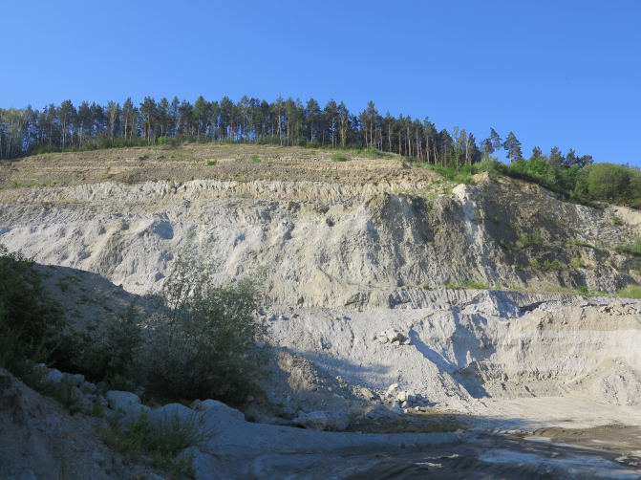 | 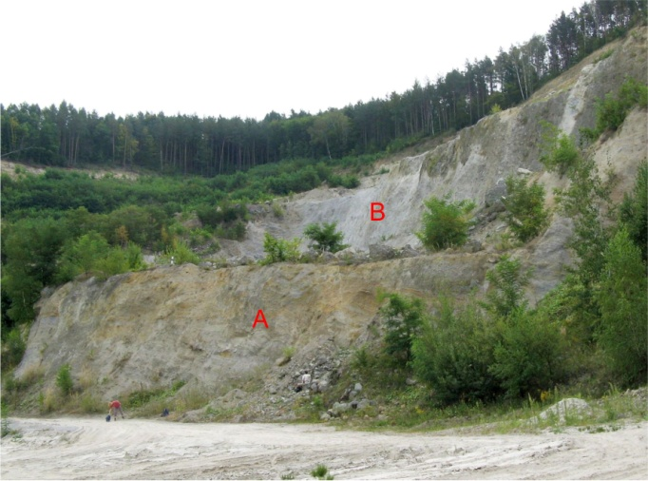
Fig. S5. Western part of the deposit. | Fig. S6. Phreatomagmatic pyroclastic rocks (A) underlying perlitic extrusive breccia (B) at the western part of the deposit.
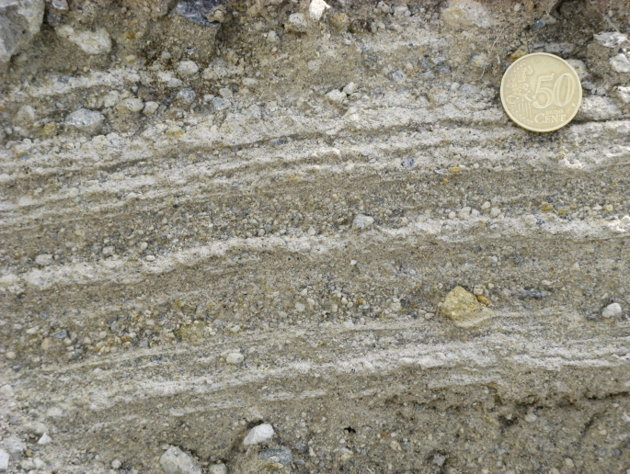 |  | 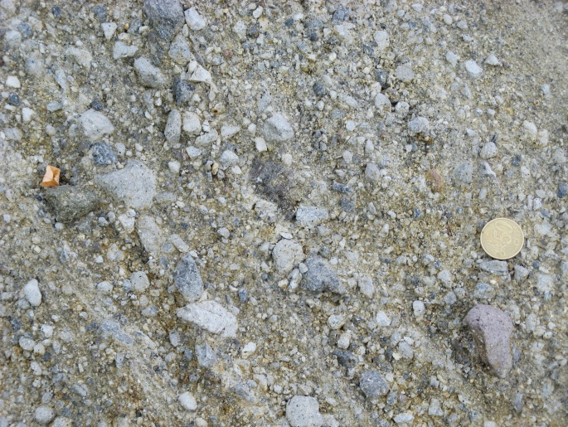
Fig. S7. Phreatomagmatic tuff showing textures typical of dry pyroclastic surge deposits (PL-4). |  | Fig. S8. Phreatomagmatic lapilli tuff composed of angular pale grey porous and dark dense perlite fragments. Note a brown andesite pebble underneth the coin (PL-10).
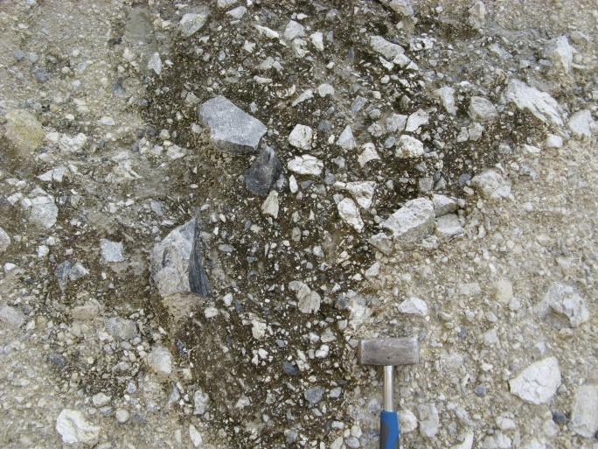 |  | 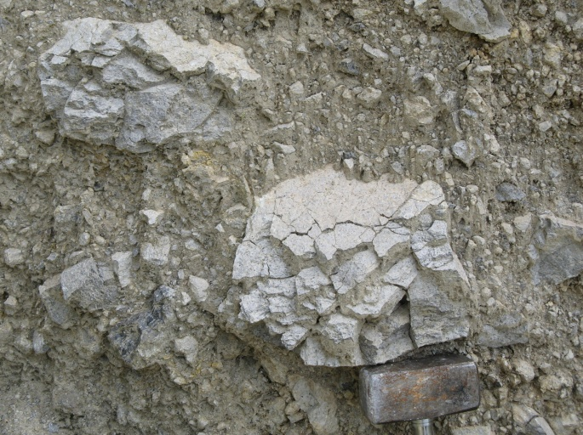
Fig. S9. Phreatomagmatic pyroclastic breccia – dominantly angular fragments indicate the contraction type fragmentation due to fast cooling at the contact with groundwater (PL-6). |  | Fig. S10. Chilled balistic blocks of pale grey pumiceous perlite in phreatomagmatic pyroclastic breccia (PL-6).

Phreatomagmatic fine breccias and lapilli tuffs of the pyroclastic ring are covered and southward laterally succeeded by a thick accumulation of coarse perlitic extrusive breccia of the hyaloclastite type (Lexa 1971) – an object of the past exploitation. The extrusive hyaloclastite breccia is matrix supported, unsorted, chaotic, only locally showing incipient stratification dipping around 30⁰ north to northwest (in the area of exploited deposit), apparently related to local mass wasting on slopes of the breccia pile (Figs. S11–S14). Perlitic rhyolite glass fragments and blocks are angular, up to 60 cm in diameter. Average size of fragments is 5 – 15 cm. Fine detritic matrix represents 10 – 30 %. As in the underlying pyroclastic rocks, perlite fragments and block are dominantly porous to pumiceous of pale grey colour, less frequent there are dark to black fragments of dense perlite.
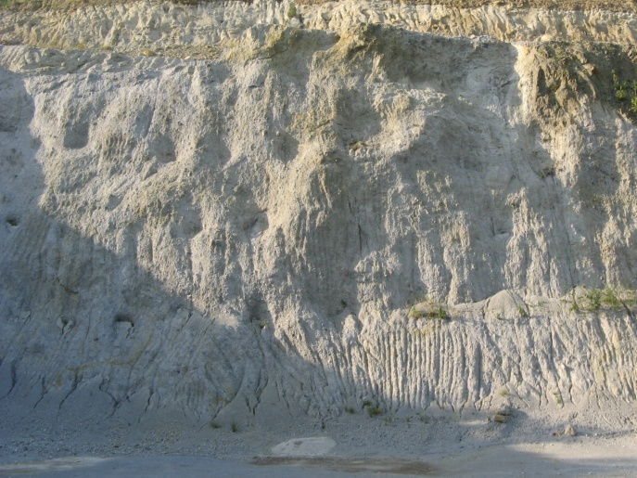 | 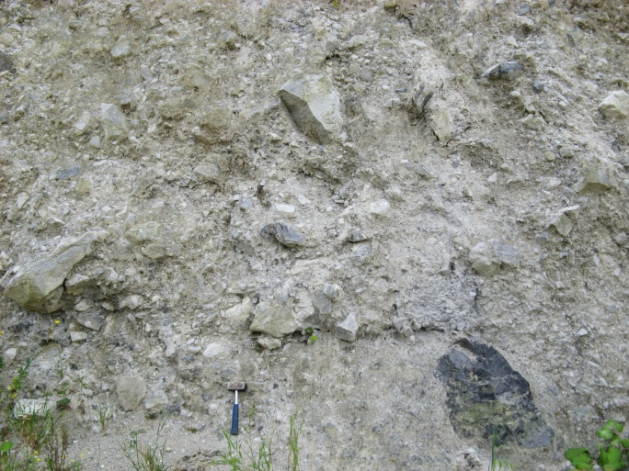
Fig. S11. A thick accumulation of perlitic extrusive breccia – the object of exploitation (PL-172). | Fig. S12. Coarse to blocky perlitic extrusive breccia with dominant pale grey porous to pumiceous fragments/blocks and subordinate dark dense fragments/blocks (PL-20).
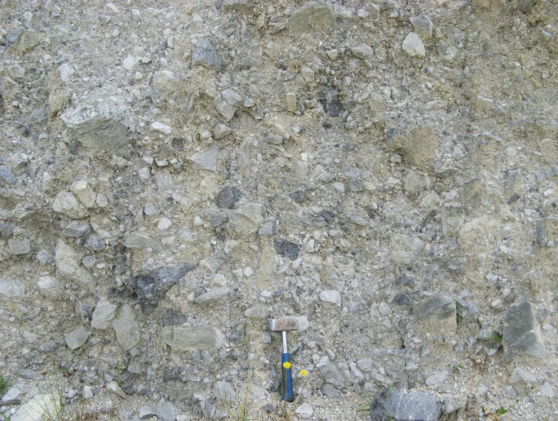 | 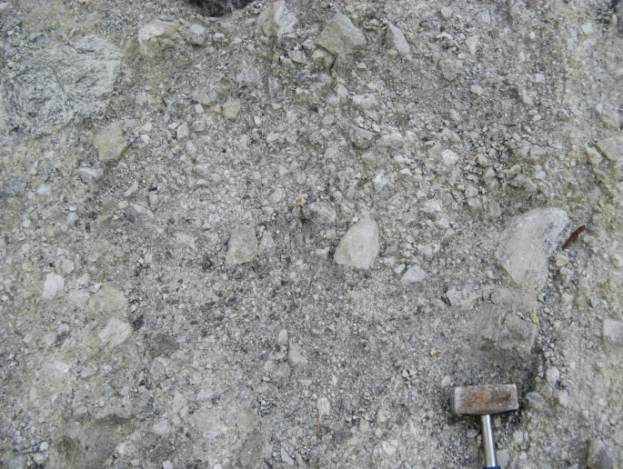
Fig. S13. Coarse perlitic extrusive breccia – dominantly angular fragments indicate the contraction type of fragmentation due to fast cooling at the contact with groundwater (PL-20). | Fig. S14. Relatively fine perlitic extrusive breccia with less frequent dark dense fragments (PL-22).
In the western part of the deposit the extrusive perlitic breccia is covered conformably by two lava flows, dipping 35º north and 30º northwest, respectively. The one dipping northward is 5 – 7 m thick, formed of coherent lava with eutaxitic texture that passes upward into autoclastic breccia with vesicular fragments (Figs. S15 and S16). The one dipping northwestward is thicker, its coherent lava is of a limited extend and passes upward and laterally into matrix-poor in situ breccias of the hyaloclastite type with angular fragments and blocks (Figs. S17 and S18). Rhyolite of the lava flows is glassy and perlitic, dark and dense, similar to dark fragments in the underlying extrusive breccia. Succession in the western part of the deposits continues with a second horizon of extrusive perlitic breccia, in this case relatively enriched in fragments of dark dense perlite (Figs. S19 and S20). The topmost few meters of the breccia show a decrease in the size of fragments and increasing proportion of fine matrix (Figs. S21 and S22). Laterally, this horizon passes into accumulation of reworked material east and west of the deposits – fine to coarse epiclastic volcanic breccias (Figs. S23 and S24).
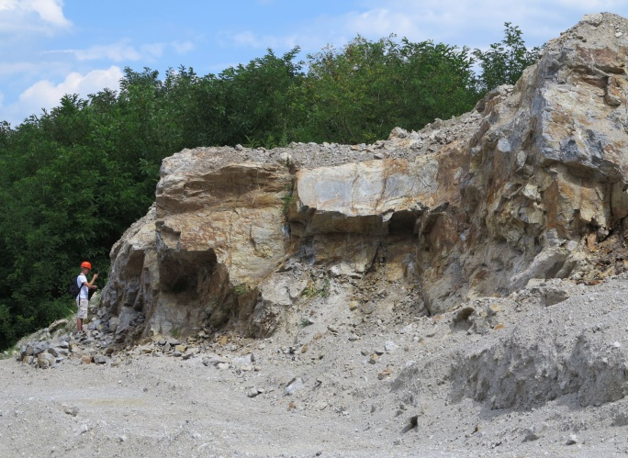 | 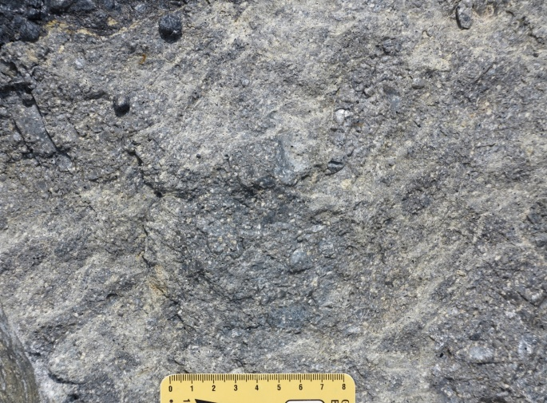
Fig. S15. Steeply dipping lava flow at the eastern side of the western part of the deposit comformable with underlying perlitic extrusive breccia (PL-299). | Fig. S16. The lava flow is formed of dark dense perlite showing fluidal/eutaxitic texture (PL-248).
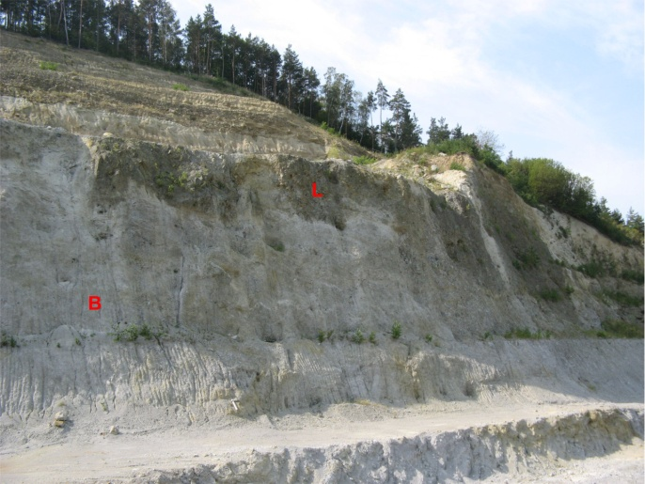 | 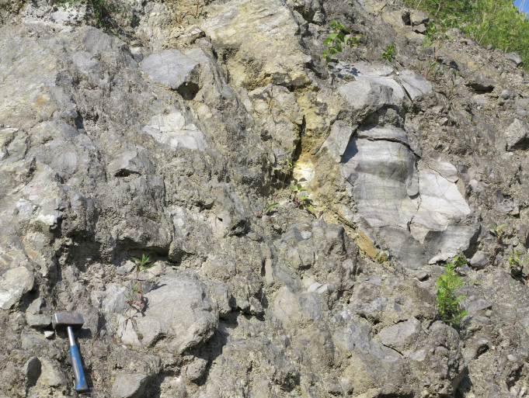
Fig. S17. Northwestward dipping lava flow (L) conform-able with underlying perlitic extrusive breccia (B) at the western side of the western part of the deposit. | Fig. S18. The lava flow is in the initial stage of the quench type of fragmentation giving rise to in situ hyaloclastite breccia (PL-19).
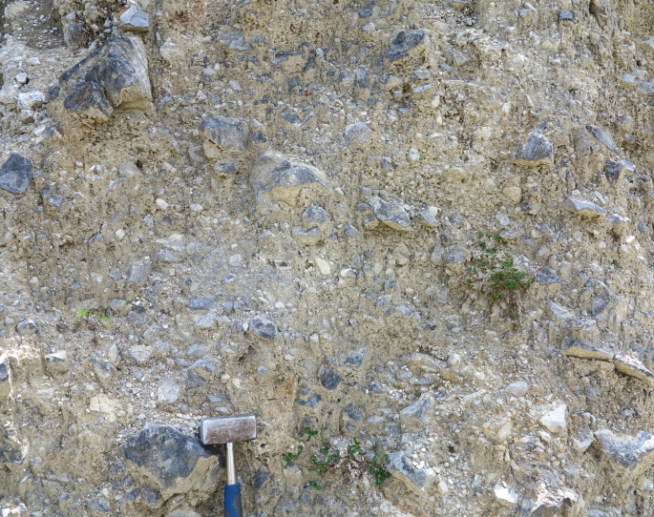 | 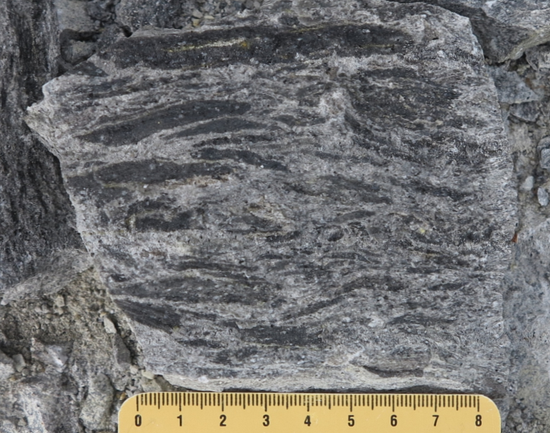
Fig. S19. Perlitic extrusive breccia above the lava flow is enriched in dark dense perlite fragments/blocks similar to the lava flow (PL-267). | Fig. S20. One of the fragments in perlitic extrusive breccia above the lava flow showing eutaxitic texture charcteristic of the underlying lava flow (PL-255).
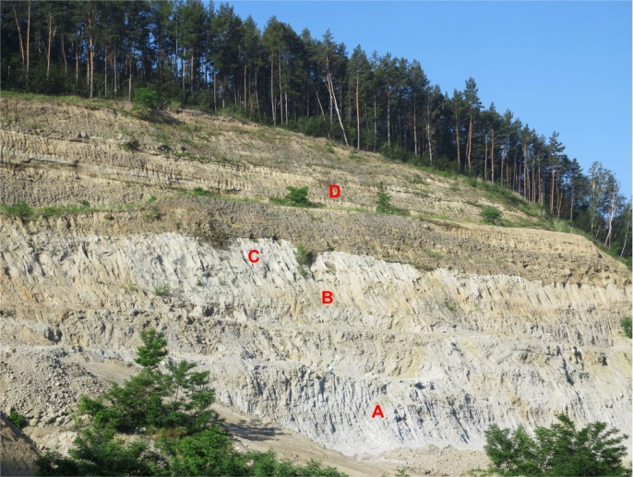 | 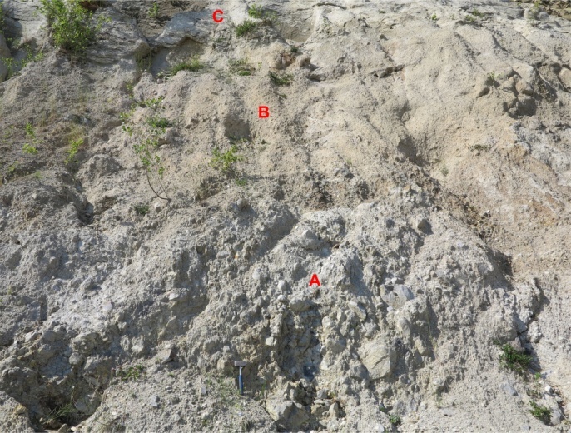
Fig. S21. Top of the western part of the deposit: A – exploited perlitic extrusive breccia; B – eluvial horizon at the top of the extrusive breccia; C- the fall-type tuffs; D – overlying fluvial conglomerates and sandstones. | Fig. S22. Detail of the top of the western part of the deposit: A – perlitic extrusive breccia; B – the elluvial/ delluvial type of relatively fine perlite surficial deposits; C – the fall-type tuffs (PL-216).
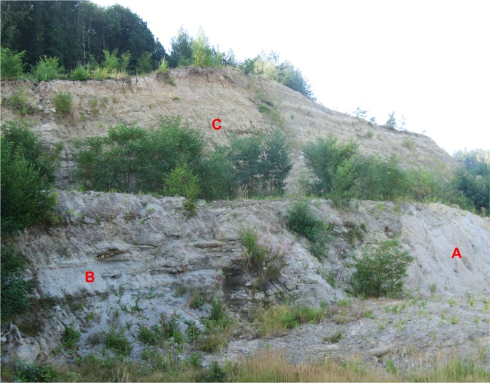 | 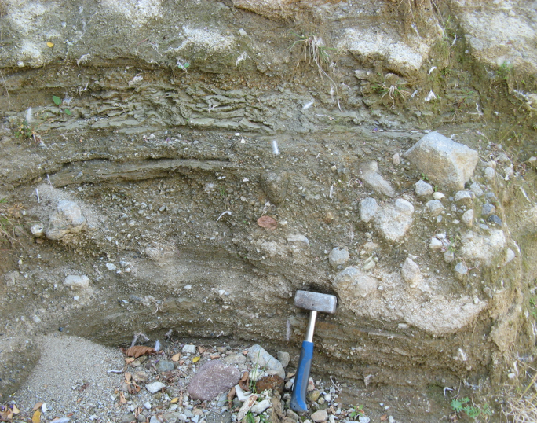
Fig. S23. Epiclastic volcanic breccias and sandstones (B) – a product of local reworking atop of the perlitic extrusive breccia (A) at the eastern part of the deposit; C – overlying fluvial conglomerates and sandstones (PL-89). | Fig. S24. Detail of epiclastic volcanic breccias and sandstones from the Fig. S27.
Tuffs composed dominantly of perlitic material represent the uppermost unit of the monogenetic volcano (Fig. S21). They are well sorted and stratified, showing mantle bedding conformable with morphology of underlying extrusive breccia accumulation (Fig. S25). The described succession of the monogenetic volcano units was subsequently levelled by erosion and covered by slightly younger sub-horizontal accumulation of fluvial conglomerates and sandstones (Figs. S21 and S26).
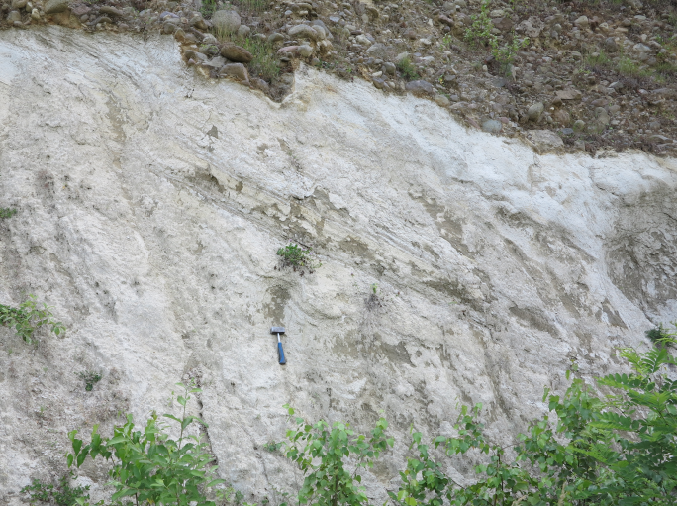 | 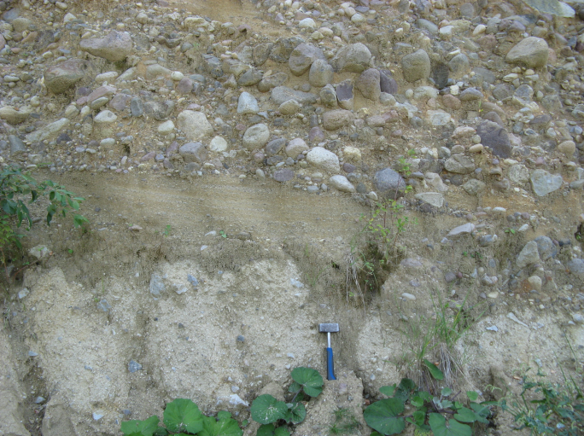
Fig. S25. Steeply dipping stratified and well sorted fall-type tuffs in the western part of the deposit rest comformably on perlite extrusive breccia (bellow the hammer) (PL-225). | Fig. S26. In the western part of the deposit fluvial conglomerates and sandstones rest also directly on the eroded surface of perlite extrusive breccia (PL-35).
At the south-western and southern parts of the volcano (beyond limits of the deposit) there are two rhyolite cryptodomes that are emplaced in extrusive perlitic breccias and underlying phreatomagmatic pyroclastic rocks (Figs. S27–S30). Felso-spherulitic rhyolite in their internal parts passes close to their contacts with surrounding rocks through glassy spherulitic rhyolite into dark and dense perlitic rhyolite glass at their margins. However, at their tops felso-spherulitic rhyolite passes into pale altered breccias showing recrystallization of former glass fragments and incipient silicification.
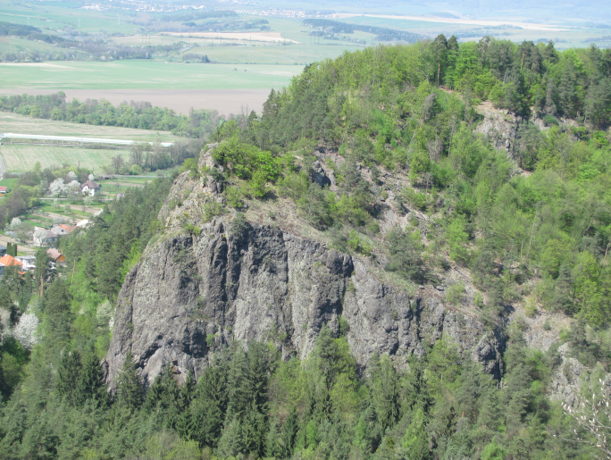 | 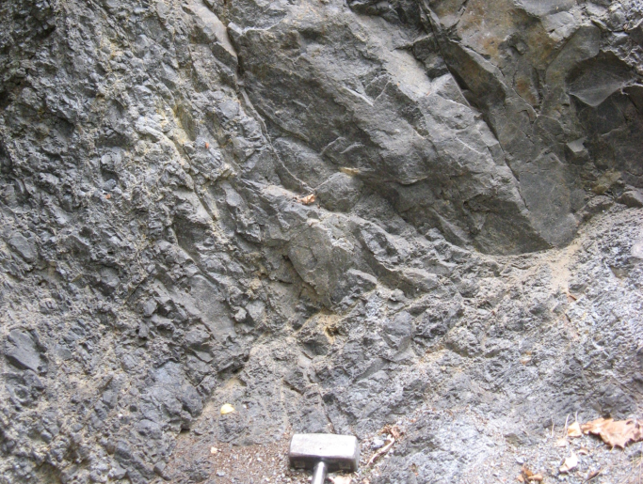
Fig. S27. Cliff of the Szabóova skala – a cryptodome exposed by erosion of surrounding breccias and tuffs. | Fig. S28. Dark dense perlite at the margin of the cryptodome showing the contraction type of jointing /fragmentation (SS-3).
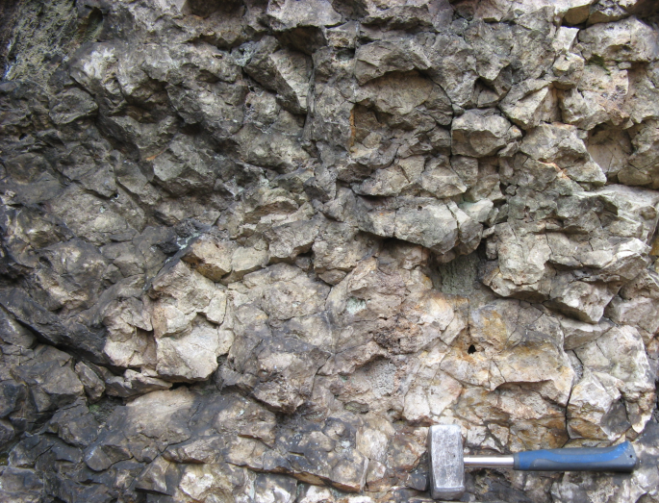 | 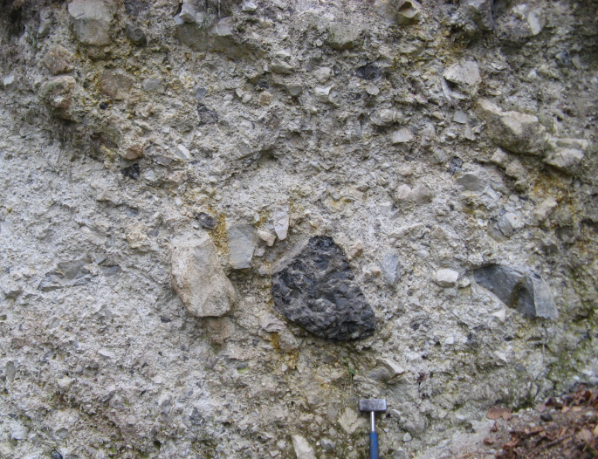
Fig. S29. Pale silicified breccia at the top of the Szabóova skala cryptodome (SZ-7). | Fig. S30. Perlitic extrusive breccia next to the margin of the Szabóova skala cryptodome (SS-1).
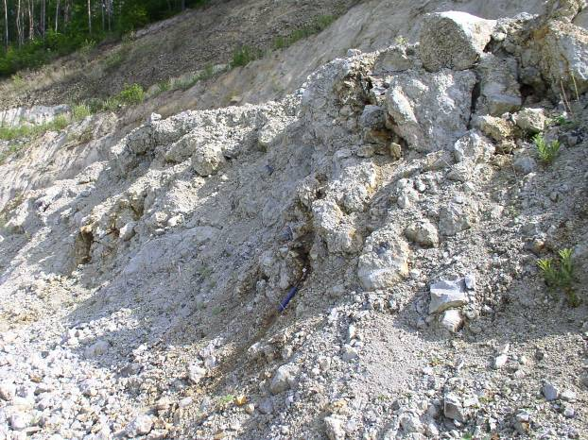 | <<< Fig. S31. Several brown/rusty zones of altered perlite (fossil fumaroles?) in the upper part of perlitic extrusive breccia in the western part of the deposit.

The Jastrabá perlite deposit (Jastrabá rhyolite monogenetic volcano)
The Jastrabá monogenetic volcano that hosts the perlite deposit is represented by an extrusive dome-flow, related extrusive breccias and a fan of block and ash flow deposits, tuffs and epiclastic volcanic breccias that nowadays occur in an inverted mutual position (Figs. S32, S33). The asymmetric dome with the centre at the Jastrabá skala turns into short coulées. Internal parts of the dome and coulées are formed of variably vesicular pink to reddish felso-spherulitic rhyolite, locally, especially close to margins, showing banded texture (Fig. S34). At contacts with older rocks and extrusive breccia felso-spherulitic rhyolite of the dome and coulées passes into perlitized glassy rhyolite, often showing initial stages of brecciation.
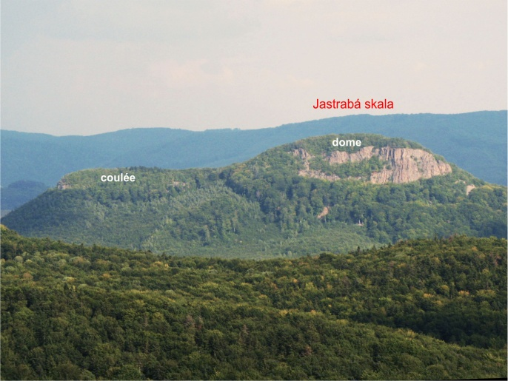 | 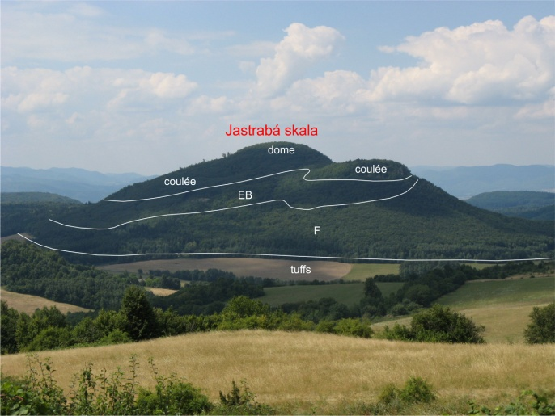
Fig. S32. View of the Jastrabá skala volcano from west with the dome and northern coulée indicated. | Fig. S33. View of the Jastrabá skala volcano from northeast with extent of litological units indicated; EB – perlitic extrusive breccia, F – fan of pyroclastic and epiclastic rocks next to the dome.
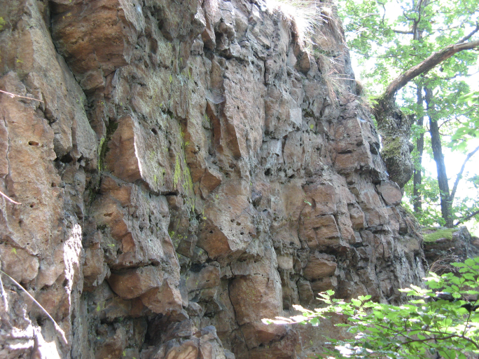 | 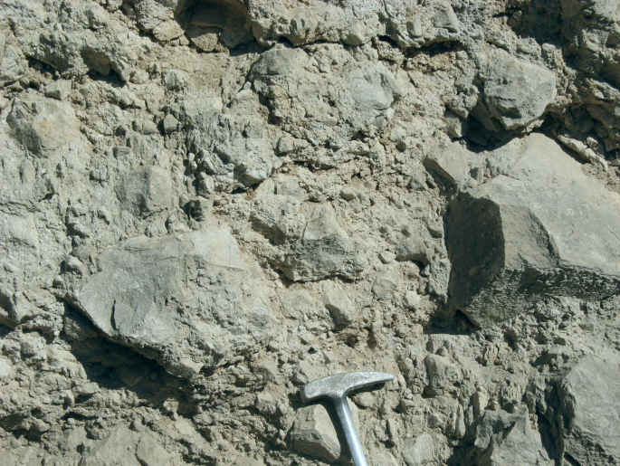
Fig. S34. Felso-spherulitic rhyolite at the base of the cliff on the western side of the dome showing inward- dipping flow banding (JS-10). | Fig. S35. Blocky perlitic breccia – a part of the Jastrabá deposit perlite resource; grey angular blocks and fragments are porous (JS-2).
Perlitic extrusive breccias that represent perlite resources of the deposit are coarse to blocky, chaotic and unsorted (Figs. S35, S36). Angular, often polygonal fragments and blocks are of a quite uniform appearance, pale grey or pink, porous to pumiceous, often showing flow banding (alternation of darker and pale bands). Larger blocks show radial jointing and disintegration on polygonal fragments. Fragments in the range 5 – 20 cm dominate, while rare blocks show diameter up to 50 cm. Proportion of fragments varies between 50% and 80%. Unsorted matrix is composed of fine to coarse perlite detritus.
The fan associated with a growing extrusive dome is composed of irregularly alternating breccias of block and ash flows, the fall and/or surge type lapilli tuffs and tuffs and fine to coarse epiclastic volcanic breccias laid down by debris and hyperconcentrated flows
(Fig. S37). While pyroclastic and epiclastic breccias form thicker massive unsorted beds, the surge type tuffs and hyperconcentrated flow deposits show a typical poor to moderate sorting and a planar/laminar stratification and fall tuffs are well sorted, showing typical mantle bedding. The material of these deposits represents dominantly perlite similar to perlite of the extrusive breccia. Rare felso-spherulitic rhyolite fragments are of the same type as the interior of the dome and related coulées.
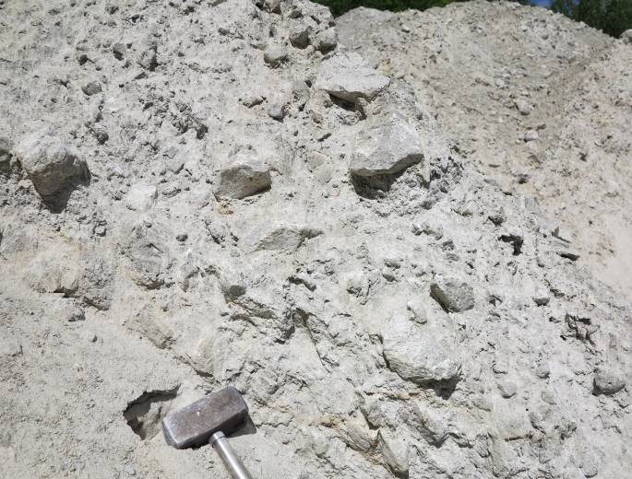 | 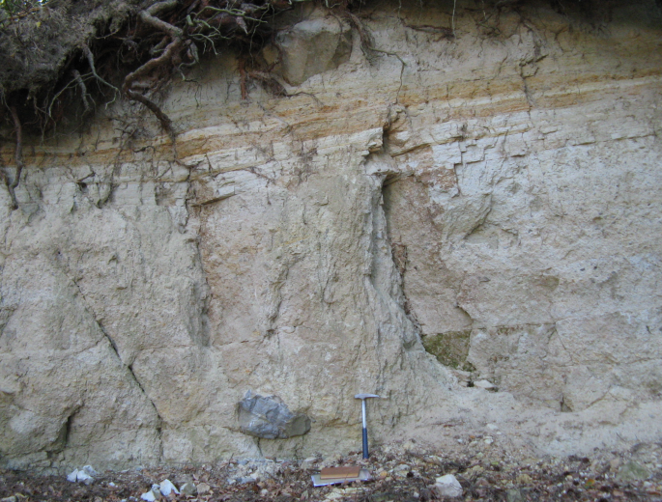
Fig. S36. Blocky perlitic breccia – a part of the Jastrabá deposit perlite resource; pale grey fragments and blocks are porous to pumiceous (JS-22). | Fig. S37. Block and ash pyroclastic flow deposits covered by a horizon of stratified and sorted fall tuffs laid down on a fan surrounding the dome (JA-6).

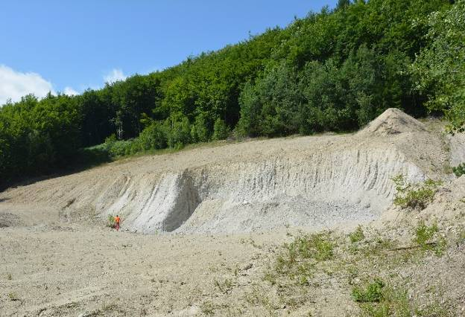 | 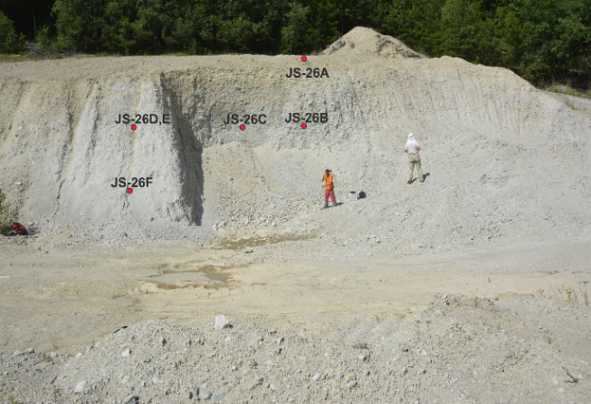
Fig. S38. Uncovered part of the Jastrabá deposit. | Fig. S39. Localization of samples at the Jastrabá perlite deposit.
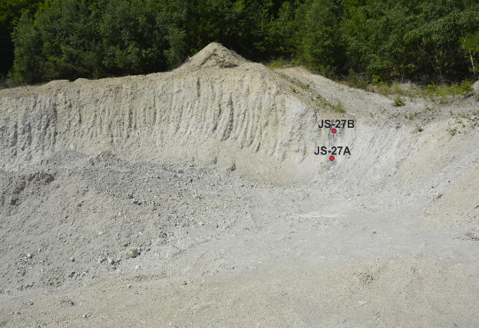 | 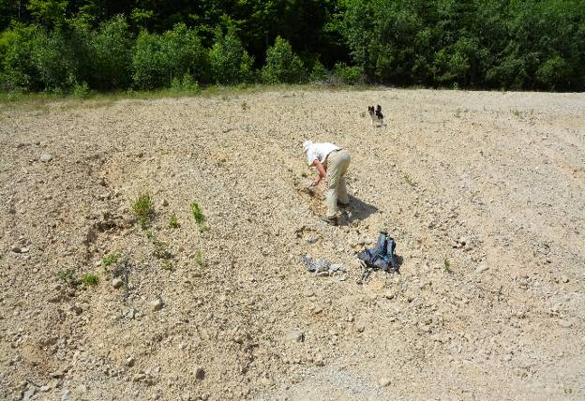
Fig. S40. Localization of samples at the Jastrabá perlite deposit. | Fig. S41. Partly weathered surface of the perlitic extrusive breccia (JS-28).

References
Beňo J. & Očenáš D. 1962: Lehôtka pod Brehmi – perlite, final report and reserves assessment. Open file report, Archive of the State Geological Institute of D. Štúr, Bratislava, 1–79 (in Slovak).
Forgáč J., Brestenská E., Klabenová K., Planderová E., Sitár V. & Škvarka L. 1974: Structural boreholes HF-1 (Hliník nad Hronom) and JL-1 (Jalná). Regionálna geológia Západných Karpát 4, 1–109 (in Slovak).
Lexa J. 1971: Forms of rhyolite bodies in surroundings of Žiar nad Hronom. Geologické Práce – Správy 56, 67–80 (in Slovak with English summary).

