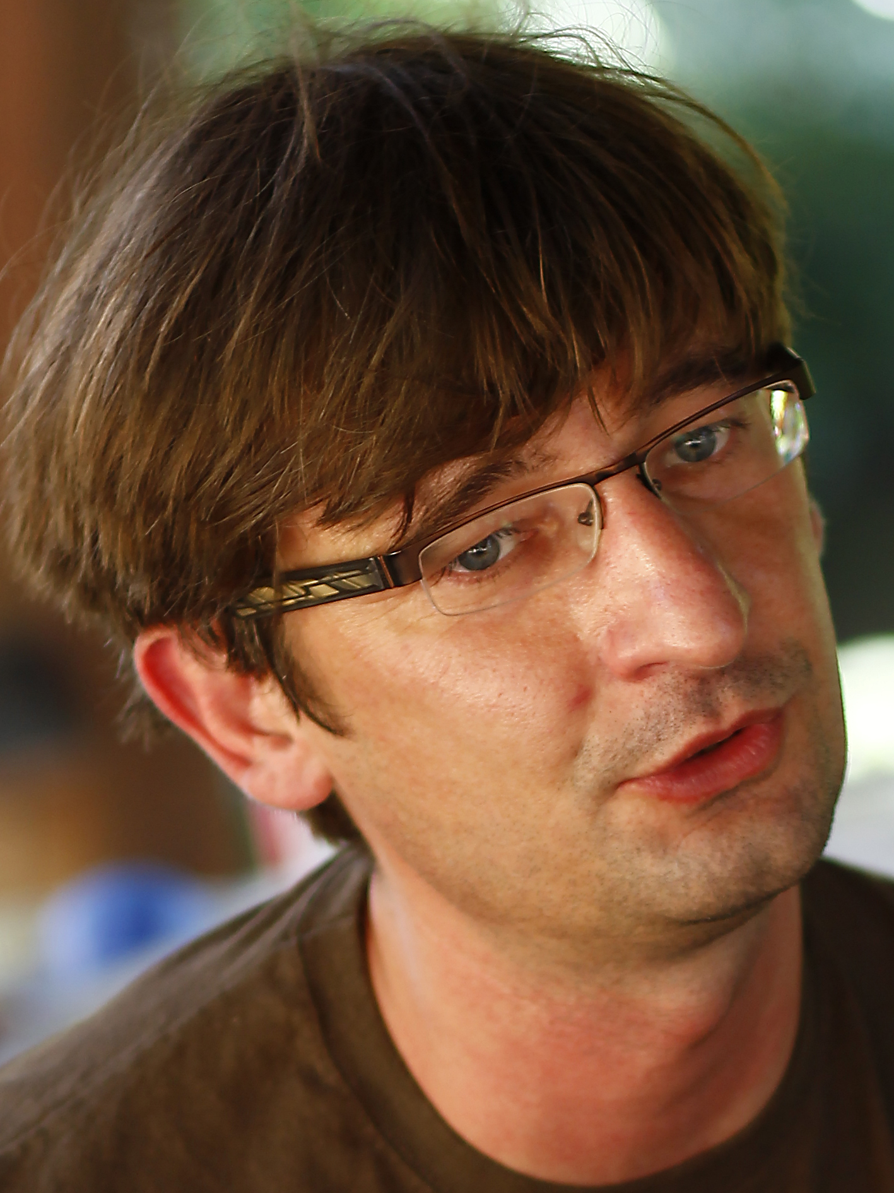

Personal information
Name Ján Tkáč
Nationality Slovak
Date of birth 10.5.1972
Place of birth Poprad
Employment: Institute of Chemistry SAS, Dúbravská cesta 9, 845 38 Bratislava;
Glycanostics s.r.o., Kudláková 7, 841 01 Bratislava

Study and emloyment
1990 - 1995 University studies - field of biotechnology, FChPT STU
1995 - 1997 Scholarship, Department of Biotechnology FChPT STU
1997 - 2000 PhD. studies - Department of Biotechnology, FChPT STU
2000 - 2001 Postdoc, Institute of Chemistry SAS
2001 - 2003 Postdoc, Linkopings University, Sweden
2003 - 2006 Postdoc, Lunds University, Sweden
2006 - 2008 Postdoc, Oxford University, UK
2009 - Independent researcher, Institute of Chemistry SAS
2010 – 2018 Chairman of the Scientific Council, Chemical Institute of the Slovak Republic
2011 - Senior researcher, awarded the title of DrSc., Chemical Institute of the Slovak Academy of Sciences
2012 - 2016 Member of the scientific grant agency VEGA
2013 - Head of the Department of Glycobiotechnology, Chemical Institute of the Slovak Republic
2013 - 2016 Editor for the journals Chemical Papers and Open Chemistry
2014 – 2018 Member of the Accreditation Commission
2014 - Tutor in the field of Biotechnology
2015 - 2019 Member of the Scientific Council of FChPT STU
2017 - Member of the Learned Society
2017 - Founder of Glycanostics
2017 - 2020 Expert reviewer for Microchimica Acta (IF=4,580)
2018 - Member of the scientific commission awarding the DSc. degree in Analytical Chemistry
2018 - Member of the scientific commission awarding the DSc. degree in Biotechnology
2018 - Member of the scientific commission awarding the DSc. degree in Biochemistry
2022 - Member of the Accreditation Commission at FChPT STU
2022 - Member of the Accreditation Commission

Awards
2003 - 2006 Recipient of the prestigious Individual Marie Curie Fellowship - Lunds Universitet, SE
2006 Member of the winning team of the Nanochallenge 2006 global competition of business ideas
2011 Member of the team awarded the SAS Award for scientific research activity
2013 Member of the SAS top team
2013 – 2017 Recipient of the prestigious ERC Starting grant (Chemical Institute of the Slovak Republic)
2014 Award of the Minister of Education "Small Medal of Samuel Mikovíni" for international scientific cooperation
2014 Member of the SAS top scientific team awarded by ARRA independent assessment
2016 The most significant result in science works for the year 2015 (II. Department of SAS) in cat. international science projects
2016 Scientist of the Year 2015
2017 The most significant result in science work for the year 2016 (II Department of SAS) in cat. international science projects
2017 Top scientific project evaluated by the APVV agency
2018 Science and technology award in the category "Science and technology team of the year"
2018 The most significant result in science work for the year 2017 (II Department of SAS) in cat. international science projects
2018 Prize for work with the highest IF in cooperation with the SAV and AVČR, 100th anniversary of the founding of Czechoslovakia
2018 - 2020 Responsible researcher of the prestigious ERC Proof of Concept grant (SAV Institute of Chemistry and Glycanostics)
2018 3rd place in the Vodafone Idea of the Year International Business Plan Competition (Glycanostics)
2018 Future Now – top 6 startup awards (Glycanostics)
2019 Recipient off the prestigious grant SME Instrument 1 (H2020) with the start-up Glycanostics
2019 ESET Science Award
2019 Central European Startup Awards: Best HealthTech & Best Social Impact Startup (Glycanostics)
2019 Accace Life Accelerator winner (Glycanostics)
2020 World Summit: Best Startup in CE countries & Special Prize in European final (Glycanostics)
2020 Future of Health: Best Startup award final (Glycanostics)
2021 Chief Scientist implementing the prestigious EIC Accelerator grant (Glycanostics)
2021 Seal of Excellence for the prestigious EIC Transition grant (Glycanostics)

Scientific outputs
151 publications (articles & chapters), 3700+ citations (source: SCOPUS, no self-citations), h=33 (SCOPUS, no self-citations) and 1 patent application
ResearchGate: https://www.researchgate.net/profile/Jan_Tkac
Google Scholar: https://scholar.google.sk/citations?user=jfkqa18AAAAJ&hl=sk&oi=ao

