PERSOAL INFORMATION | RNDr. Magdaléna Strečková, PhD.
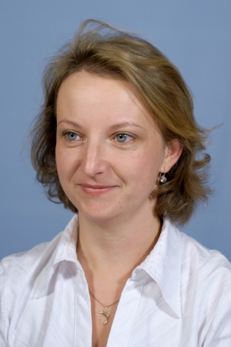 | Cezmínová, 3, 040 22, Košice, Slovak Republic
 | +421-55-7922 455
 | mstreckova@saske.sk
 | Sex: Female |:Natioanlity SK

Current  Work position | Senior Researcher IMR SAS

EXPERIENCE

(FROM 2014 -TO 2018)  (From 2010 -TO 2014)  (From 2007 -TO 2008)  EDUCATION  ( FROM2002 -TO 2005)  (FROM 1997 - TO 2002) | Senior researcher IMR SAS
 | Institute of Materials Research, Watsonova 47, 040 01 Košice
Design and development of new carbon-based fibrillary materials with incorporated nanoparticles prepared by electrospinning for efficient hydrogen evolution. Characterization of prepared materials by the most modern methods in the field of nanomaterials. Solving of tasks within projects APVV, VEGA MAD and SF..
Economy sector : Materials engineering-composites
Scientific researcher IMR SAS
Institute of Materials Research, Watsonova 47, 040 01 Košice

Preparation, characterization, chemical synthesis and development of methodology of micro and nano composite materials. Use of polymer systems for preparation of micro and nano-copolymer materials. Analysis of microstructure and chemical properties of newly formed composites. Development of advanced technologies for the preparation of micro- and nano-composite materials for electrical engineering.
Economy sector : Materials engineering-composites

Scientific researcher Faculty of Science Pavol Jozef Šavárik University
Institute of chemistry, FS UPJŠ, Moyzesova 16, 041 54 Košice,
Leading of laboratory and computational exercises of chemistry, Exercises of physical and analytical chemistry, advanced and electrochemical processes

PhD study at FS UPJŠ (PhD.) EKR 8
Institute of chemistry, FS UPJŠ, Moyzesova 16, 041 54 Košice,
PhD study in the field of analytical chemistry focusing on electrochemical processes

Master study (Mgr.) EKR 7
Institute of chemistry, FS UPJŠ, Moyzesova 16, 041 54 Košice
Master study in the field of physical and analytical chemistry (Mgr.)

OSOBNÉ ZRUČNOSTI

Mother language | Slovak
Other languages | UNDERSTANDING |  | SPEAKING |  | WRITING
 | Listening | reading | Oral interaction | Separate oral expression
English | C1 | C1 | C1 | C1 | C1
German | B2 | B2 | B2 | B2 | B2
Levels: A1 / A2: User Basics - B1 / B2: Individual - C1 / C2 Experienced
Common European Framework of Reference for Languages

Communication skills | - good communication skills acquired as a project manager  - communicativeness, reliability, independence, flexibility
Organizational and management skills | Organizational skills within project management MAD, VEGA, APVV bilateral

Digital skills | SELF EVALUATION
 | Processing information | Communication | Content creation | Safety | Troubleshooting
 | Independent user | Independent user | Independent user | Independent user | Independent user
Levels: User Basics - Standalone - Experienced user
Digital Skills - Self Assessment Table
- good knowledge of Word word processor, Excel spreadsheet, Power point presentation software
- good control of Corel, Paint photo editing software and chemical software such as Chem 3D pro, Chem Draw Ultra 12

Driving license | B

Additional information

Publication  Projects | 52 WOS, SCOPUS  Leader or coworker of VEGA, MAD, APVV, SF projects

